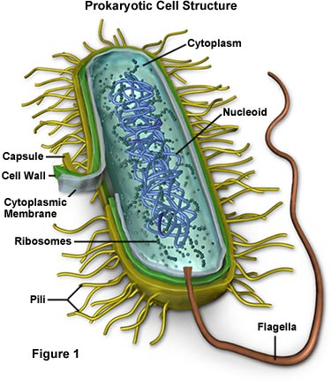
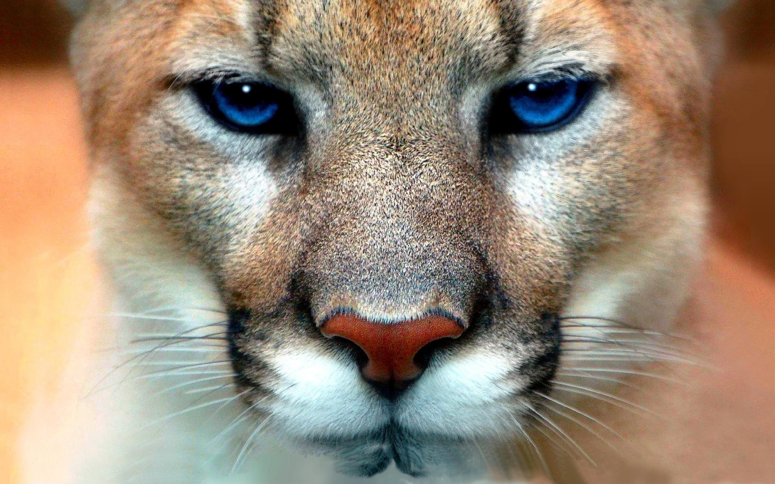
Honors Biology Syllabus
Mr. Hilton
York Comprehensive High School
Room E-202
Email: chilton@york.k12.sc.us
Website: codeyhilton.weebly.com
School Phone: (803) 684-2336

Dear parent/guardian,
Thank you for taking the time to read the syllabus and class expectations. To be truly successful in educating your child, parents/guardians and teachers must work together throughout the year. Please feel free to contact me via email at. Please make sure that if you email me, please put your student’s name in the email. The information is this syllabus is always subject to change!
Thank you for your time and consideration!

YCHS Mission
YCHS will create a student-centered educational environment for students that challenge them to maintain high levels of motivation and achievement while instilling the Discipline, Respect, Perseverance, Scholarship, and Excellence they need to succeed in college and other post-secondary opportunities.

Description of Course
Biology is an exciting course that surveys the study of life! We will be investigating many biological questions and will work to discover answers and come up with more unanswered questions. Biology is an EOC class and passing this course is required for graduation! Together, we will make sure you are prepared to ace the exam at the end of the semester! I maintain a class website that contains all the information needed for your student to be successful. The website is: www.codeyhilton.weebly.com.

Big Goal
Biology is a very important class. Not only do you need to pass this class to graduate, you will also gain an understanding of biology that will help you in college and in your everyday life! My BIG GOAL for you is that all students will average at least an 80% on all biology objectives and that every single one of you will pass the EOC at the end of the semester!

Materials Needed
The materials you bring for my class will be used for Biology alone. Required materials must be brought to class every day so that you are prepared for success! Materials must be obtained by Monday. Please come see me ASAP if materials are not available to you.

Required Materials | Required Materials
- 1 ½ or 2” binder for Biology ONLY | - Colored Pencils
- Pens or pencils | - Markers
- 8 binder dividers | - Scissors
- Notebook paper | - Hand sanitizer
Marble Composition Notebook | - Ear buds that are Chromebook compatible

Classroom Expectations
The expectations outline how you should behave and ensure that everyone in the class is safe and can learn. These expectations are in addition to ALL YCHS rules!!!
- Be on time with all materials and ready to learn
- Respect yourself and others
- Listen to directions the first time
- Always have a positive attitude
- Follow YCHS policies
This includes but is not limited to:

- Tardy Policy
Students will have three (6) minutes between classes to get to their next class.
Late students will ONLY be admitted to class with a valid pass. Late students will be documented and further action will be taken for excessive tardiness which includes but is not limited to administration referrals.

- Late Work Policy
Students are expected to turn all assignments in ON TIME. If a student fails to turn in work the day it is due, he/she may turn in late work. However, as the teacher, I do have the right to deduct points each day the assignment is late.

- Absences
Any person more than 20 minutes late to class is considered absent. I will update my teacher website weekly with all class assignments, homework, and notes as well as the corresponding PowerPoints. It is the student’s responsibility to find out what was missed and ask questions if he/she needs clarification. If absent, the student is responsible for obtaining all notes as well as turning in any missed work. If work was assigned BEFORE the student was absent, it is due the day he/she returns. If work was assigned DURING the absence, he/she will have 3 days to turn in the make-up work before points will be deducted (see Late Work Policy). It is YOUR responsibility to seek make-up work. If you fail to do so, you will receive a zero for that assignment. Make-up work will not be completed during class time.
Students who are absent in semester-long classes for more than 5 days may be at risk of being sent to the attendance recovery committee.

- Classroom Culture
We will work hard to have a positive classroom culture this year and our number one rule will be respect. In instances where that respect or our classroom culture is disrupted, consequences will be issued to include loss of free time or privileges, calls home, or meetings with the administration. Our class will be treated like a family. You might not always like all family members, but you will always love them and treat them with respect.

Positive Consequences | Negative Consequences
- Positive parent contact | 1. Verbal warning
- Homework pass | 2. Official Warning with a seat change
- Content mastery and academic success! | 3. One on One Discussion/Redirection
 | 4. Parent contact
 | 5.Classroom Write Up
 | ***I reserve the right to call home at any point***
Grade Weights
50% Tests and Projects
25% Labs/Quizzes
25% Classwork, & Homework
The Final Exam (EOC) counts 20% of the final grade!!!
YCHS Grading Policy*
A 90-100%
B 80-89%
C 70-79%
D 60-69%
F 59% and below
*please note that YCHS has adopted a 10 point grading scale

Biology Units
Unit 1: Intro to Lab Sciences & Tools | Unit 6: Heredity
Unit 2: Molecular Biology & Cell Structure and Function | Unit 7: Evolution
Unit 3: Cell Cycle | Unit 8: Adaptations, Ecology, and Ecosystems
Unit 4: Cellular Energy | Unit 9: EOC Review
Unit 5: Protein Synthesis and Genetics | **Unit 10: Classification and Taxonomy (if time allows)**

Academic Honor Policy
Each student will use an Honor Statement to reflect his or her commitment to abide by this policy.

I want YOU to succeed! Please come to tutoring and use enrichment effectively!
I am here for YOU!!!
Be proactive about YOUR education and YOUR future!

By signing below, I have read the syllabus and understand the expectations outlined in it. Also please feel free to include any pertinent information about your student below.

Student signature: __________________________________ Date: _____________________

Parent/Guardian signature: ___________________________________ Date: _____________________

