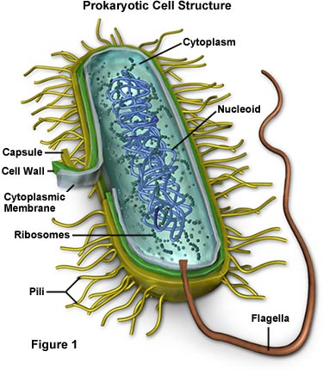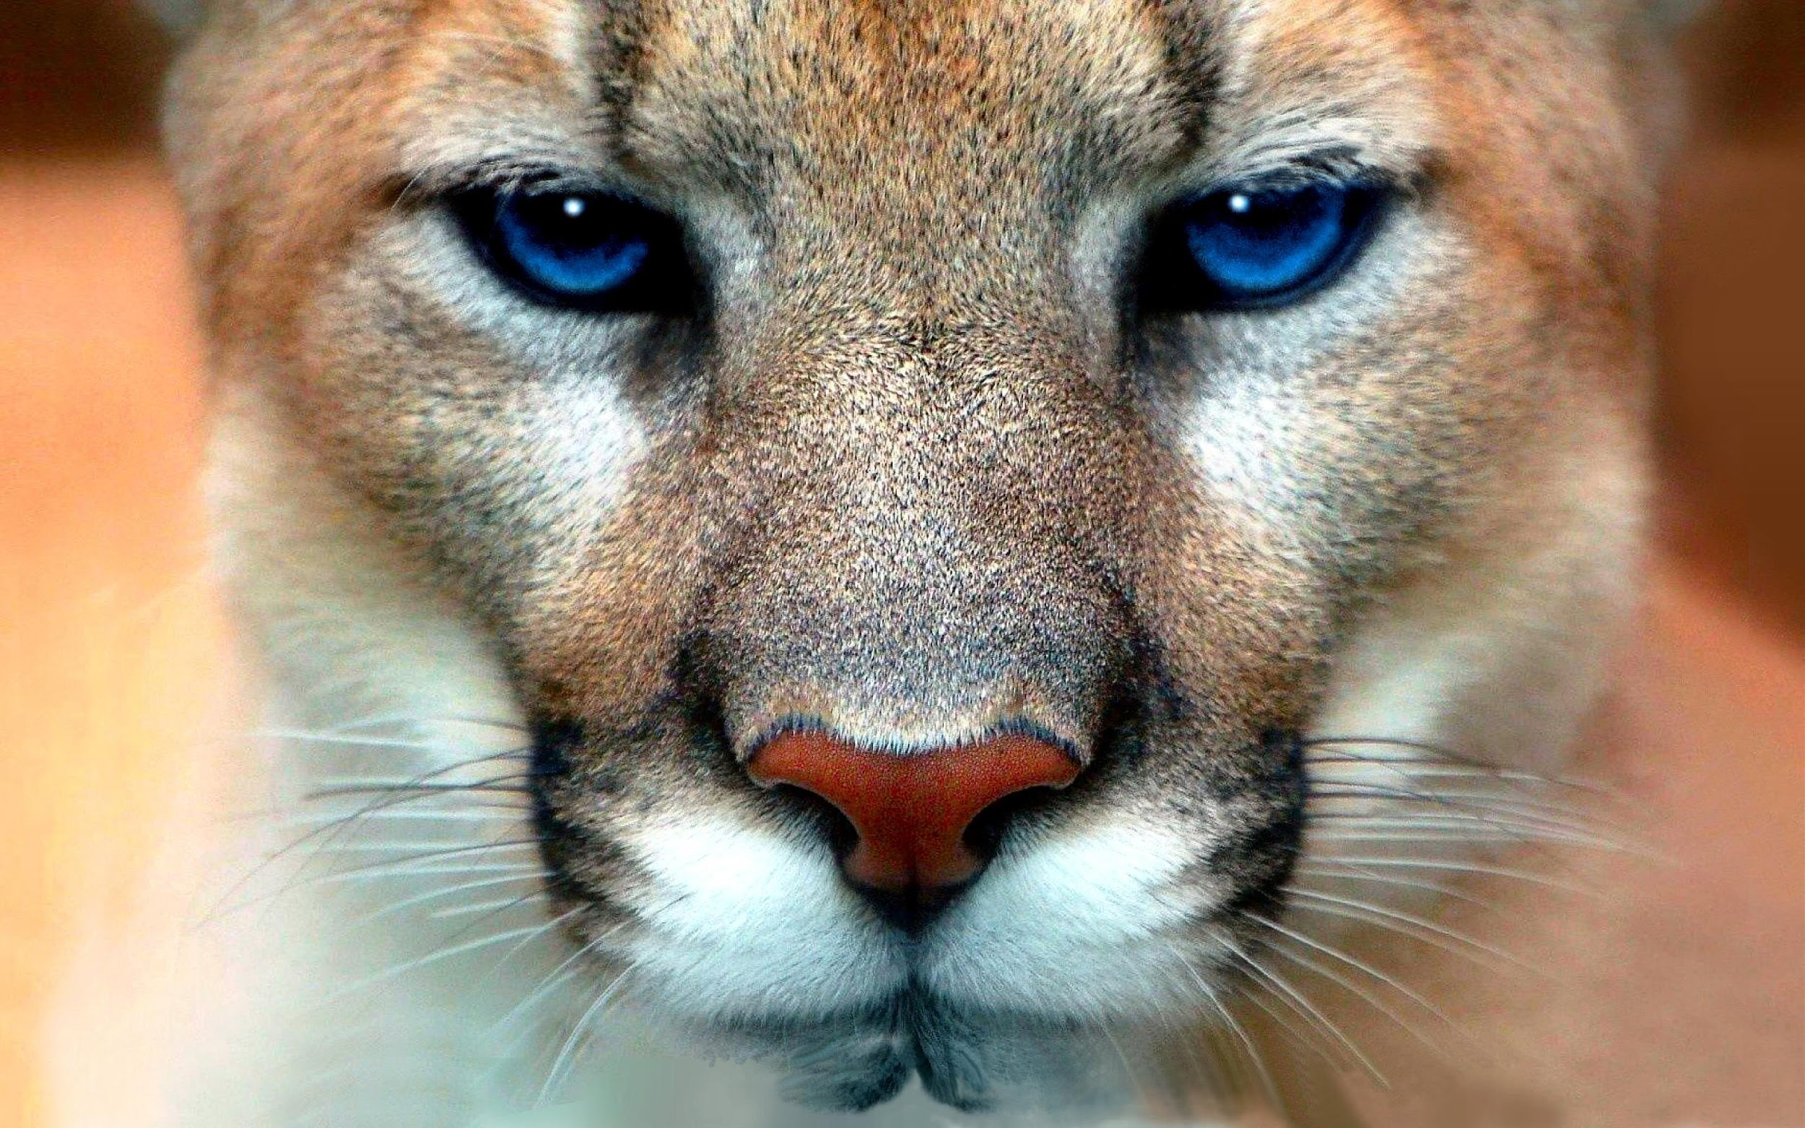

**Biology 1 – CP**

This course offers a survey of fundamental characteristics of living organisms. Areas of study are: scientific inquiry; structure and function of cells; the flow of energy involving living things; genetics and heredity; evolution; and interrelationships among living things and their environment. Lectures, films and lab sessions are essential parts of instruction. This course counts a lab science for college admission in SC. An End of Course examination will be given at the conclusion of the course.

**Prerequisite**: Physical Science/Integrated Science **Grades 9-12; 1 Unit**

**Teacher Name: Mr. Codey Hilton Room: E-202**

**Contact Information for Teacher: E-mail:** [**chilton@york.k12.sc.us**](mailto:chilton@york.k12.sc.us)

**Extra help is available from 8:00 am – 8:35 am daily, or by appointment after school**

**Biology Syllabus**

**Mr. Hilton**

York Comprehensive High School

Room E-202

Email: chilton@york.k12.sc.us

Website: codeyhilton.weebly.com

School Phone: (803) 684-2336



**Dear parent/guardian,**

**Thank you for taking the time to read the syllabus and class expectations. To be truly successful in educating your child, parents/guardians and teachers must work together throughout the year. Please feel free to contact me via email at chilton@york.k12.sc.us. Please make sure that if you email me, please put your student’s name in the email. The information is this syllabus is always subject to change!**

**Thank you for your time and consideration!**

**YCHS Mission**

YCHS will create a student-centered educational environment for students that challenge them to maintain high levels of motivation and achievement while instilling the Discipline, Respect, Perseverance, Scholarship, and Excellence they need to succeed in college and other post-secondary opportunities.

**Description of Course**

Biology is an exciting course that surveys the study of life! We will be investigating many biological questions and will work to discover answers and come up with more unanswered questions. **Biology is an EOC class and passing this course is required for graduation**! Together, we will make sure you are prepared to ace the exam at the end of the semester! I maintain a class website that contains all the information needed for your student to be successful. The website is: **www.codeyhilton.weebly.com.**

**Big Goal**

Biology is a very important class. Not only do you need to pass this class to graduate, you will also gain an understanding of biology that will help you in college and in your everyday life! My BIG GOAL for you is that all students will average at least an **80%** on all biology objectives and that every single one of you will pass the EOC at the end of the semester!

**Materials Needed**

The materials you bring for my class will be used for Biology alone. Required materials must be brought to class every day so that you are prepared for success! Materials must be obtained by **Monday.** Please come see me ASAP if materials are not available to you.

|  |  |
| --- | --- |
| **Required Materials** | **Required Materials** |
| * 1 ½ or 2” binder for Biology **ONLY** | * Colored Pencils |
| * Pens or pencils | * Markers |
| * 8 binder dividers | * Scissors |
| * Notebook paper | * Hand sanitizer |
|  | * Ear buds that are Chromebook compatible |

**Classroom Expectations**The expectations outline how you should behave and ensure that everyone in the class is safe and can learn. **These expectations are in addition to ALL YCHS rules!!!**

1. **Be on time with all materials and ready to learn**
2. **Respect yourself and others**
3. **Listen to directions the first time**
4. **Always have a positive attitude**
5. **Follow YCHS policies**

**Beginning Class**

• Be in your assigned seat working quietly on the Warm-Up assignment when the bell rings.

• Have your homework and materials ready.

• Clear desktop of purses and book bags.

**During Class**

• Listen to the teacher with full attention.

• Write notes and any examples worked for you.

• Stay on task and in your assigned area.

**Ending Class**

• Turn in all completed assignments.

• Clean up and put away materials.

• Remain in your seat until the bell rings.

\***Restroom Policy\***

You should visit the restroom between classes. In the event of an emergency, you will be allowed to go to the restroom. If you abuse my trust by going to an unauthorized area, you will lose this privilege.

\***Leaving Class\***

Students are expected to be in class at all times. Students will not be allowed to leave unless summoned by office staff or Administration.

**\*Phones, music players (including ear buds), and other non-school issued electronic devices are prohibited at all times. \***

1. **Tardy Policy**

Students will have three (6) minutes between classes to get to their next class.

Late students will **ONLY** be admitted to class with a valid pass. Late students will be documented and further action will be taken for excessive tardiness which includes but is not limited to administration referrals.

1. **Late Work Policy**

Students are expected to turn all assignments in **ON TIME**. If a student fails to turn in work the day it is due, he/she may turn in late work. However, as the teacher, I do have the right to deduct points each day the assignment is late. My current policy is a 10% deduction per day.

1. **Absences**

Any person who misses more than 20 minutes of class is considered absent. I will update my teacher website weekly with all class assignments, homework, and notes as well as the corresponding PowerPoints. It is the student’s responsibility to find out what was missed and ask questions if he/she needs clarification. If absent, the student is responsible for obtaining all notes as well as turning in any missed work. If work was assigned BEFORE the student was absent, it is due the day he/she returns. If work was assigned DURING the absence, he/she will have **3 days** to turn in the make-up work before points will be deducted (see Late Work Policy). It is **YOUR** responsibility to seek make-up work. If you fail to do so, you will receive a zero for that assignment. Make-up work will not be completed during class time. Students who are absent in semester-long classes for more than 5 days may be at risk of being sent to the attendance recovery committee.

1. **Classroom Culture**

We will work hard to have a positive classroom culture this year and our number one rule will be respect. In instances where that respect or our classroom culture is disrupted, consequences will be issued to include loss of free time or privileges, calls home, or meetings with the administration. Our class will be treated like a family. You might not always like all family members, but you will always love them and treat them with respect.

|  |  |
| --- | --- |
| **Positive Consequences** | **Negative Consequences** |
| * Positive parent contact | 1. Verbal warning |
| * Homework pass | 2. Official Warning with a seat change |
| * Content mastery and academic success! | 3. One on One Discussion/Redirection |
|  | 4. Parent contact |
|  | 5.Classroom Write Up |
|  | ***\*\*\*I reserve the right to call home or email at any point\*\*\**** |

**Grade Weights**

40% Tests and Projects

30% Labs

30% Quizzes, Classwork, & Homework

**The Final Exam (EOC) counts 20% of the final grade!!!**

**\*YCHS Grading Policy\***

A 90-100%

B 80-89%

C 70-79%

D 60-69%

F 59% and below

|  |  |
| --- | --- |
| **Biology Units** | |
| Unit 1: Intro to Lab Sciences & Tools | Unit 6: Heredity |
| Unit 2: Molecular Biology & Cell Structure and Function | Unit 7: Evolution |
| Unit 3: Cell Cycle | Unit 8: Adaptations, Ecology, and Ecosystems |
| Unit 4: Cellular Energy | Unit 9: EOC Review |
| Unit 5: Protein Synthesis and Genetics | **Unit 10: Classification and Taxonomy (if time allows) ** |
|  |  |

**Academic Honor Policy**

Each student will use an Honor Statement to reflect his or her commitment to abide by this policy.

**I want YOU to succeed! Please come to tutoring and use enrichment effectively!**

**I am here for YOU!!!**

**Be proactive about YOUR education and YOUR future!**

***\*\* Please read the entire course syllabus and Flinn Safety Contract carefully. Sign and return this last page.***

***Keep your course syllabus and safety contract in your notebook for future reference.***

***STUDENT***

***I have read and understood the procedures and expectations, classroom rules and consequences, grading***

***procedures, and missed class/late assignments policy as described in Mr. Hilton’s course syllabus. I will put forth my best efforts in achieving these expectations and abiding by the procedures and rules at all times. I***

***understand that these policies are in conjunction with those set forth by the administration of York Comprehensive High School, which will be enforced at all times.***

***Student Name ________________________________________________________ Date ____________________***

***Student Signature ___________________________________________________***

***I have read and agree to follow all of the safety rules set forth in the Flinn Scientific Student Safety Contract. I realize that I must obey these rules to ensure my own safety, and that of my fellow students and instructors. I will cooperate to the fullest extent with my instructor and fellow students to maintain a safe lab environment. I will also closely follow the oral and written instructions provided by the instructor. I am aware that any violation of this safety contract that results in unsafe conduct in the laboratory or misbehavior on my part, may result in my removal from the laboratory and a grade of zero points for that assignment.***

***Student Name __________________________________________________________ Date ____________________***

***Student Signature _____________________________________________________***

***PARENT/GUARDIAN***

***I acknowledge that I have read and understand the classroom expectations and policies as outlined in Mr.***

***Hilton’s course syllabus. I will instruct my student to uphold the agreement to follow classroom rules and***

***procedures at all times. I understand that these policies are in conjunction with those set forth by the***

***administration of York Comprehensive High School, which will be enforced at all times.***

***Parent/Guardian Name ___________________________________________________ Date ________________***

***Parent/Guardian Signature ______________________________________________***

***I acknowledge that I have read and understand the lab safety rules and expectations as outlined in the Flinn Lab***

***Safety Agreement. I am aware of the measures taken to ensure the safety of all students in the science***

***laboratory, and will instruct my student to uphold the agreement to follow these rules and procedures in the***

***laboratory. I understand that a violation of lab safety protocol may result in the removal of my student from the***

***lab activity and zero points awarded for that assignment.***

***Parent/Guardian Name __________________________________________________________ Date _____________***

***Parent/Guardian Phone ___________________________________________________________***

***Parent/Guardian Email____________________________________________________________***

***Parent/Guardian Signature ______________________________________________________***

***Also, please feel free to include any pertinent information about your student below.***