|  |  |
| --- | --- |
| **Step 1: Transcription** | |
|  | |
| **WHAT** is it? |  |
| **WHERE** does it happen? |  |
| **WHY** is this step necessary? | DNA holds the _________ code for a living organism inside the _____________. But proteins are made at ___________________. mRNA acts like the ________________ and takes the code from the _____________ to the ________________ in the cytoplasm where the protein can be made. |
| **HOW** does it occur? | **STEPS:**   1. **UNZIP:** An ________________ unzips the DNA 2. **MAKE mRNA:**Use the DNA template to make __________ (messenger RNA) **REMEMBER!:** RNA uses ___ instead of ___ 3. **LEAVE:** mRNA leaves the ________________ and goes into the _____________ to find a ribsome. |
| You try it!  **DNA🡪 mRNA**  *Transcribe the DNA!*  **DNA: A T C C G A G T T**  **U4-12**  **mRNA: __ __ __ __ __ __ __ __ __** | |

|  |  |
| --- | --- |
| **Step 2: Translation** | |
| **WHAT** is it? |  |
| **WHERE** does it happen? |  |
| **WHY** is this step necessary? | Messenger RNA (________) carries the genetic code from the DNA in the _________ to the ribosome in the ______________. Translation converts the ___________ message into the _______________! |
| **HOW** does it occur? | **STEPS:**   1. **FIND RIBOSOME:** mRNA attaches to a __________________ 2. **READ:** Ribosome “__________” the mRNA in groups of ___ bases (a CODON) 3. **tRNA MATCHES:** A _______ molecule comes along with the right _____________ to match the codon   CODON= UAG ANTICODON=   1. **LINK AMINO ACIDS:**the _____________ links the amino acids together with __________ bonds to make a _____________________________ (protein)! |
| You try it!  **mRNA codons🡪 anticodon**  *Translate the mRNA!*  **mRNA: U A G G C U C A A**  **tRNA anticodon: __ __ __ __ __ __ __ __ __** | |

**Protein Synthesis (making _________________!)**

**Time Out! What is RNA?!**

**U4-13**

|  |  |
| --- | --- |
| **RNA: Ribonucleic Acid** | **DNA:Deoxyribonucleic Acid** |
| http://www.biopratt.com/studyguides/Nucleic%20Acidsstudyguide_files/image002.jpg | http://www.topnews.in/health/files/dna.jpg |
| _______________ stranded | ______________ stranded |
| _______________ sugar | Deoxyribose sugar |
| **Bases:** | **Bases:** |

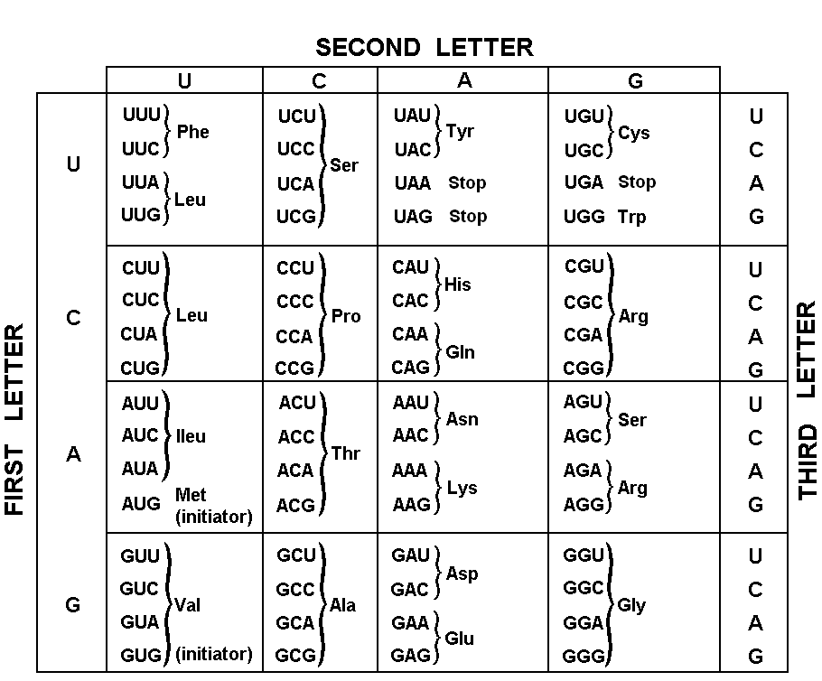**Using a Codon Chart**

**You try it!**

1. Name the amino acids that are coded by the following codons:
2. AAA= e. CAC=
3. UAC= f. UGA=
4. GGG= g. AGC=
5. GGA= h. CCC=
6. Write the amino acid sequence to make up the protein: GCA – GGU – CCA – AUG – UGC
7. Write the amino acid sequence to make up the protein: GCA – GGU – CCG – AUA – UGC

**What can we conclude?**

* _____ codon to make ____ amino acid
* But! some amino acids can be made with multiple codons!
* This means we can make the same proteins even if the codons get changed a little (_________ mutation)

**Practice protein synthesis!**

**U4-14**

**Compare and contrast DNA and RNA**

**RNA**

**DNA**

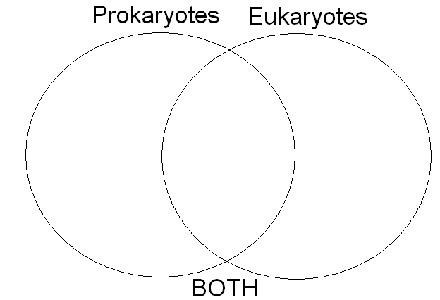

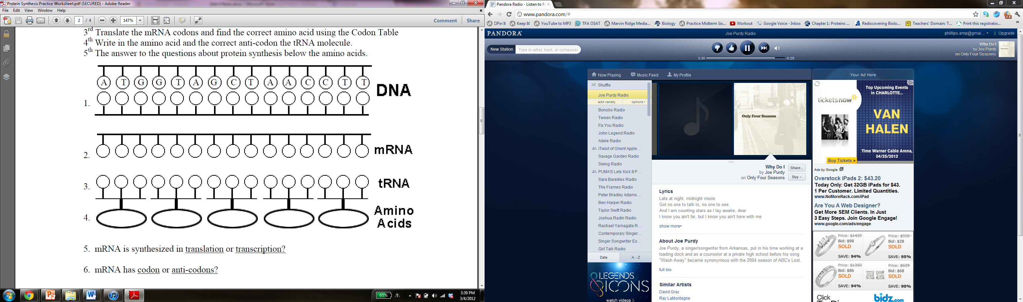

1. Is the following strand a segment of **DNA** or **RNA**?Explain how you know!

**A G C U A C C G U A C G U A**

1. Is the following strand a segment of **DNA** or **RNA**? Explain how you know!

**A C G T A C G T A G C T T A**

1. Fill in the blanks of the protein synthesis summary below:  
   DNA 🡪 mRNA = _____________________. Takes place in the ____________________.

mRNA🡪 PROTEIN = __________________. Takes place in the ____________________.

tRNA carries the __________ ___________ (2 words) that will bond together to form a polypeptide (protein).

1. Is mRNA synthesized in translation or transcription?
2. mRNA has codons or anti-codons?
3. 1 or 3 codons equal one amino acid?
4. tRNA brings amino acids to the nucleus or ribosome?
5. A polypeptide is a sequence of proteins or amino aicds?
6. tRNA transfers amino acids during translation or transcription?
7. Complete the chart below:

**U4-15**

|  |  |  |
| --- | --- | --- |
| **DNA Strand** | **Complementary DNA Strand** | **mRNA** |
| TAC GCA | ATG CGT | UAC GCA |
| TTA CAT |  |  |
| TCA ACT |  |  |
|  | GCA GTA |  |
|  |  | ACU CAG |

**Use the following DNA sequence for questions 1-4.**

**DNA🡪TAC CAT CCG GAA TCC CCT ATT**

1. After **transcription** the result would be:  
    _______________________________________
2. After **translation** the result would be:  
    _______________________________________
3. If the 10th base (indicated by the underline) was changed from a G to an A, how many amino acids would be changed? _____
4. Protein synthesis produces proteins for the cell. What are some examples of proteins that we have discussed in this class already? Name at least 2.

**EOC Practice!**

1. Amino acids link together by peptide bonds to form proteins. In which cellular organelle would this process occur?
2. Mitochondria
3. Chloroplast
4. Ribosome
5. Nucleus
6. Which of these is most responsible for carrying coded information out of the nucleus into the cytoplasm?
7. ATP
8. mRNA
9. DNA
10. tRNA
11. The process of DNA replication is necessary before a cell —
12. makes a protein
13. codes for RNA molecules
14. divides into two cells _
15. modifies lysosome enzymes
16. One strand of DNA could be as long as a football field if it were stretched out lengthwise. One of the factors allowing DNA to fit inside the nucleus of a cell is its ability to —
17. break apart into separate genes
18. extend to form very long, thin molecules
19. coil tightly around associated proteins to form chromosomes
20. denature from the effect of an enzyme
21. Genetic information usually flows in one specific direction. Which of the following best represents this flow?

|  |
| --- |
| 1. DNA → Protein → RNA |
| 1. Protein → RNA → DNA |
| 1. RNA → Protein → DNA |
| 1. DNA → RNA → Protein |

1. What process does this diagram represent?

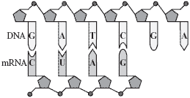

1. DNA replication
2. Transcription
3. Translation
4. Mutation

**PROTEIN SYNTHESIS**

**U4-16**

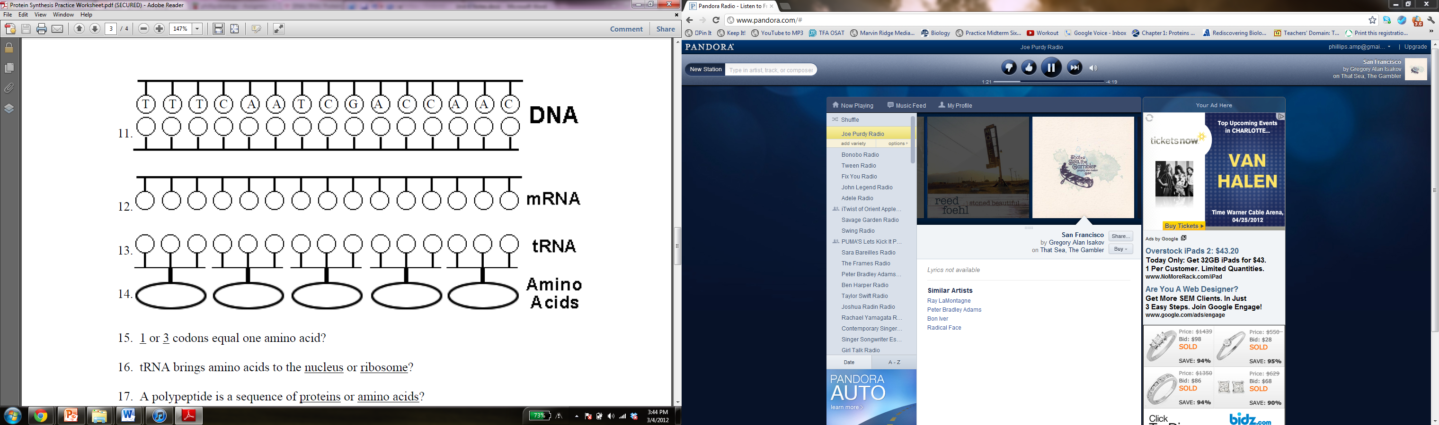

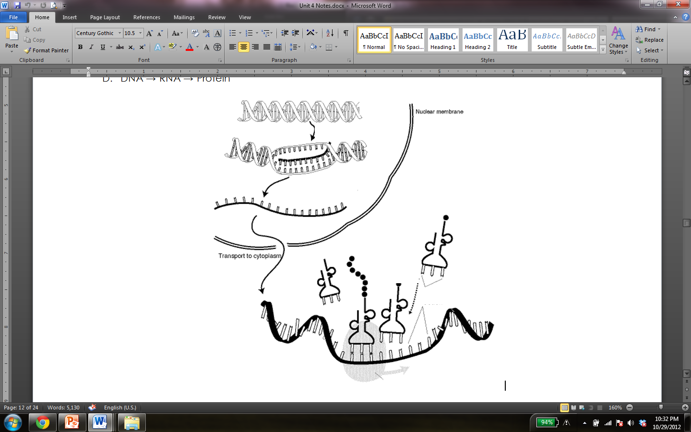

**USE THE WORDS TO LABEL THE PICTURE ABOVE:**

mRNA

mRNA

tRNA

Ribsome

DNA

TRANSCRIPTION

TRANSLATION

Nucleus

Cytoplasm

Protein (Polypeptide)

Amino acid

Codon

Anticodon

**Transcription and Translation: DO IT!**

**U4-17**

**Background:**

The instructions coded in DNA must be read and turned into protein molecules for the cell to carry out the instructions. In this activity you will model this process using sentences for DNA and RNA and words for amino acids. The words must line up in the correct order for the protein to form properly, just like words in a sentence must line up. Good luck!

**Directions**:

1. Go to the teachers’ lab bench, the **nucleus** of the cell. Select a strand of DNA that is located in the nucleus of the cell. Write down the DNA template strand number. DNA never leaves the nucleus so you must transcribe messenger RNA (mRNA) to transport the sequence of codons out of the cell. Transcribe the correct sequence of mRNA for the DNA strand selected. Remember to group your nitrogen bases in groups of three to form codons.   
   **\*REMEMBER: there is no thymine (T) in RNA. It is replaced by Uracil (U)!\***
2. The mRNA must now leave the **nucleus** and travel into the cytoplasm to locate a **ribosome** and begin translation. Your seat is a **ribosome**.
3. Once you have located your seat, a ribosome, you must find a transfer RNA (tRNA) molecule to carry the amino acid that is needed to construct a protein. One side of the tRNA holds an amino acid and the other side has an anti-codon that will pair with the codon in your mRNA. Using the base pairing rules find the tRNA molecules coded by the mRNA. Write out the tRNA anti-codon sequence.
4. Now using the tRNA anti-codon sequence , search for the correct anti-codon card on the wall. Uncover the code to reveal the corresponding word, the **amino acid**.
5. Record the **amino acid (word)** connected to the tRNA. Remember that start and stop codons will signal when it is time to start and stop a **protein (sentence)**. Write down the words in the sequence specified on the mRNA.
6. After constructing the **sentence, the protein**, check with your teacher to see your sentence is correct. If not correct, go over the same DNA template. If correct, pick another DNA template card and build another “protein”.
7. A successfully synthesized protein will result in a complete and usable sentence. If the result is a jumbled or incomplete sentence a mutation has been created and both the transcription and translation portions of the activity should be reviewed.
8. Repeat the following steps 3 more time to produce a total of 4 proteins (sentences).

**DNA Strand #: ________**

**DNA code: _____________________________________________**

**mRNA codons: ____________________________________________**

**tRNA anticodons: _____________________________________________**

**amino acids (words): ______________________________________________________**

**DNA Strand #: ________**

**U4-18**

**DNA code: _____________________________________________**

**mRNA codons: ____________________________________________**

**tRNA anticodons: _____________________________________________**

**amino acids (words): ______________________________________________________**

**DNA Strand #: ________**

**DNA code: _____________________________________________**

**mRNA codons: ____________________________________________**

**tRNA anticodons: _____________________________________________**

**amino acids (words): ______________________________________________________**

**DNA Strand #: ________**

**DNA code: _____________________________________________**

**mRNA codons: _____________________________________________**

**tRNA anticodons: _____________________________________________**

**amino acids (words): ______________________________________________________**

**Analysis Questions:**

1. In what ways do the chemical structures of DNA and RNA differ?
2. What is a codon and what does it represent?
3. What is the role of tRNA in protein synthesis?
4. You have learned that there is a stop codon that signals the end of an amino acid chain. Why is it important that a signal to stop translation be part of protein synthesis
5. What is an anti-codon?
6. What is transcription? Where does it occur?
7. What is translation? Where does it occur?
8. In the cell how could a mutation affect the synthesis of proteins?
9. What is the role of mRNA in protein synthesis?
10. Differentiate between codons and anti-codons.
11. Discuss where you had to move in the room and why. Remember, the classroom is one big cell!

**Mutations**

**U4-19**

* A change in the ________ ___________________
* They can be positive, ___________________, or neutral
* 3 types: __________________, __________________, ___________________

|  |  |  |
| --- | --- | --- |
|  | **Definition** | **Practice** |
| **Deletion** | One or more nucleotides is _____________ from the gene. | Original DNA: AAA CCC TTT GGG  Deletion mutation: ____ ____ ____ ____ ____ |
| **Insertion** | One or more nucleotides is _____________ into the gene. | Original DNA: AAA CCC TTT GGG  Insertion mutation: ____ ____ ____ ____ ____ |
| **Substitution** | One nucleotide in the DNA is replaced by another. | Original DNA: AAA CCC TTT GGG  Substitution mutation: ____ ____ ____ ____ ____ |

**Try it out!**

Directions:

1. Transcribe the DNA into an mRNA message.
2. Using your yellow codon chart translate the mRNA into its corresponding amino acid sequence.
3. Pick a number from the basket. **You will mutate nucleotide number 4.**

|  |  |
| --- | --- |
| # picked | Corresponding Action |
| 1 | Substitute the nucleotide with an A |
| 2 | Substitute the nucleotide with a C |
| 3 | Substitute the nucleotide with a G |
| 4 | Substitute the nucleotide with a T |
| 5 | Delete the nucleotide |
| 6 | Insert an A immediately after the nucleotide |

1. Write the complete DNA sequence with the one mutation in nucleotide **4.**
2. Complete the mRNA sequence from the mutated DNA.
3. Translate the amino acid sequence from the mRNA.
4. Circle any differences from the original protein produced

|  |  |  |  |  |  |  |  |  |  |  |  |  |  |  |  |  |  |  |  |  |  |
| --- | --- | --- | --- | --- | --- | --- | --- | --- | --- | --- | --- | --- | --- | --- | --- | --- | --- | --- | --- | --- | --- |
|  | 1 | 2 | 3 | 4 | 5 | 6 | 7 | 8 | 9 | 10 | 11 | 12 | 13 | 14 | 15 | 16 | 17 | 18 | 19 | 20 | 21 |
| DNA | **T** | **A** | **C** | **G** | **T** | **G** | **T** | **T** | **A** | **G** | **T** | **C** | **T** | **A** | **A** | **G** | **A** | **A** | **A** | **C** | **T** |
| mRNA |  |  |  |  |  |  |  |  |  |  |  |  |  |  |  |  |  |  |  |  |  |
| amino acid sequence |  | | |  | | |  | | |  | | |  | | |  | | |  | | |

Number picked: ________

|  |  |  |  |  |  |  |  |  |  |  |  |  |  |  |  |  |  |  |  |  |  |  |
| --- | --- | --- | --- | --- | --- | --- | --- | --- | --- | --- | --- | --- | --- | --- | --- | --- | --- | --- | --- | --- | --- | --- |
|  | 1 | 2 | 3 | 4 | 5 | 6 | 7 | 8 | 9 | 10 | 11 | 12 | 13 | 14 | 15 | 16 | 17 | 18 | 19 | 20 | 21 | 22 |
| mutated DNA |  |  |  |  |  |  |  |  |  |  |  |  |  |  |  |  |  |  |  |  |  |  |
| mRNA |  |  |  |  |  |  |  |  |  |  |  |  |  |  |  |  |  |  |  |  |  |  |
| amino acid sequence |  | | |  | | |  | | |  | | |  | | |  | | |  | | |  |

1. Did this mutation cause a change in the protein produced? Explain why or why not.
2. Is it possible to have a mutation in nucleotide 4 that would produce the same amino acid? How?

**U4-20**

Complete the boxes below. Classify each as either **deletion, insertion,** or **substitution.**

|  |  |
| --- | --- |
| **Original DNA Sequence:**  **mRNA Sequence:**  **Amino Acid Sequence:** | **TACACCTTGGCGACGACT**  ______________________________________________________ |
|  |  |
| Mutated DNA Sequence #1:  Mutated mRNA Sequence:  Mutated Amino Acid Sequence:  Will there likely be effects?:  What kind of mutation is this?: | **TACATCTTGGCGACGACT**  _________________________________________________________ _________________________________________________________ _________________________________________________________ _________________________________________________________ |
|  |  |
| Mutated DNA Sequence #2:  Mutated mRNA Sequence:  Mutated Amino Acid Sequence:  Will there likely be effects?:  What kind of mutation is this?: | **TACGACCTTGGCGACGACT**  _________________________________________________________ _________________________________________________________ _________________________________________________________ _________________________________________________________ |
|  |  |
| Mutated DNA Sequence #3:  Mutated mRNA Sequence:  Mutated Amino Acid Sequence:  Will there likely be effects?:  What kind of mutation is this?: | **TACACCTTAGCGACGACT**  _________________________________________________________ _________________________________________________________ _________________________________________________________ _________________________________________________________ |
|  |  |
| Mutated DNA Sequence #4:  Mutated mRNA Sequence:  Mutated Amino Acid Sequence:  Will there likely be effects?:  What kind of mutation is this?: | **TACACCTTGGCGACTACT**  _________________________________________________________ _________________________________________________________ _________________________________________________________ _________________________________________________________ |
|  |  |
| Mutated DNA Sequence #5:  Mutated mRNA Sequence:  Mutated Amino Acid Sequence:  Will there likely be effects?:  What kind of mutation is this?: | **TACACCTTGGGACGACT**  _________________________________________________________ _________________________________________________________ _________________________________________________________ _________________________________________________________ |

**U4-21**

**Real life mutations: 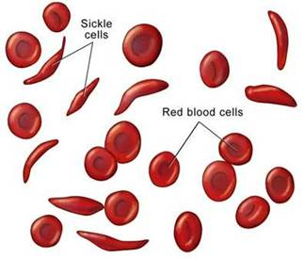Sickle Cell Anemia**

Sickle cell anemia is the result of a type of mutation in the gene that codes for part of the hemoglobin molecule. Recall that hemoglobin carries oxygen in your red bloods cells. The mutation causes the red blood cells to become stiff and sickle-shaped when they release their oxygen. The sickled cells tend to get stuck in blood vessels, causing pain and increased risk of stroke, blindness, damage to the heart and lungs, and other conditions.

Analyze the DNA strands below to determine what amino acid is changed and what type of mutation occurred.

|  |  |
| --- | --- |
| **Normal Hemoglobin**  DNA: **C A C G T G G A C T G A G G A C T C C T C**  mRNA: _____________________________________________  Protein: _____________________________________________ | **Sickle Cell Hemoglobin**  DNA: **C A C G T G G A C T G A G G A C A C C T C**  mRNA: _____________________________________________  Protein: _____________________________________________ |

1. How many amino acids changed in the mutated hemoglobin molecule?
2. What type of mutation causes sickle cell? (insertion, deletion, or substitution)

**Gene Regulation**

Genes can be turned ____ and ____ when they are needed.

**1. Environmental influences**

Different genes are expressed (turned on) depending on the ____________________ of the cell.

**2. Cell Specialization**

Different genes are _________________ depending on the specific ___________ of the cell.

**Ex.** Liver cells will turn on different genes than muscle cells, because they have completely different jobs

*TIMING IS EVERYTHING!*

**1. Injury repair:** Sometimes, it is beneficial for your body to produce __________ of new proteins, such as when you break a bone or cut your skin: new proteins aid in the ____________ process

**2. Cancer:** Other times, proteins are created at the __________ time, which causes ________________ celldivisionleading to ____________ that may cause cancer

**U4-22**

Cell Specialization: Each cell in an organism has a special job

* How do we make them?
  + All cells start out the same way (called _________ __________). The ___________ tells it what to become, and it makes special proteins to do the job it is told to do

|  |  |  |
| --- | --- | --- |
| **Specialized Cell** | **Explanation** | **Picture** |
| **Red Blood Cells** | Are shaped like a bowl to carry ______________ molecules; have no nucleus! *Remember: the protein ____________ is what binds to the oxygen molecules!* |  |
| **Muscle Cells** | Have more ____________________ than others to make more _______________! |  |
| **Xylem cells** | Transport _________ from the _______ to the leaves. |  |
| **Phloem cells** | Transport ___________ throughout the plant (from the ______________). |  |
| **Guard cells/ Stomata** | Act like mouths to _______ and ________, letting _______ in and out of the leaves { _____ in, ____out] |  |
| **Intestinal Villi** | Tiny, ________________ projections that protrude from the inner lining of the ____________ wall.  ___________ the ____________ area of the intestinal wall, resulting in better ______________ of nutrients! |  |

**Unit 4 Study Guide**

**U4-27**

**Vocabulary Review**  
______ 1. DNA A. Turning mRNA into a protein; happens in the ribosomes  
______ 2. RNA B. Cells that can become any cell in the body; used for research  
______ 3. DNA replication C. Genes can be turned on and off as needed  
______ 4. Transcription D. A mistake during DNA replication that can be good, bad, or neutral

______ 5.Translation E. Using living organisms to develop new products and technologies  
______ 6.Protein F. A nucleic acid made of deoxyribose sugar and the bases A,T, C, or G  
______ 7. Codon G. Making new strands of identical DNA; happens in nucleus  
______ 8. Mutation H. A nucleic acid made of ribose sugar and the bases A, U, C, or G  
______ 9. Gene regulation I. A molecule made up of amino acids connected by peptide bonds  
______10. Biotechnology J.The process of separating DNA by size to make a DNA fingerprint  
______11. Gel electrophoresis K. Turning DNA into a mRNA message; happens in the nucleus  
______12. Human genome project L. A project to sequence all of the base pairs in human DNA  
______13. Stem cells M. A group of 3 bases that tRNA matches an amino acid to  
  
**DNA Review**

1. What occurs during **transcription**? _________________________________________

2. **Where** in the cell does **transcription**occur? ________________________________

3. What occurs during **translation**? ___________________________________________

4. **Where** in the cell does **translation** occur? __________________________________

Turn the DNA into a protein:

**DNA:TACAGGCGCTCTGACAAAAGAATT**

**mRNA**: _________________________________________________________________

**Protein**:



1. In your own words, what is **cloning**?
2. Which suspect is linked to the crime scene by this DNA analysis?

How can you tell? What process made this image?

1. True or False: All of an organism’s genes are always turned on. ___________  
   Explain:
2. True or False: Mutations can be good or bad. ___________  
   Explain:
3. Write a sentence that explains how the following four words are related: **DNA, PROTEIN, TRAIT, RNA**