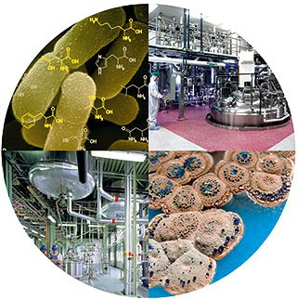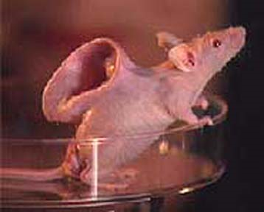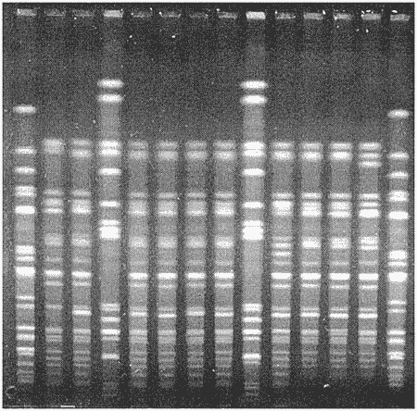**Unit 5: Protein Synthesis &Biotechnology**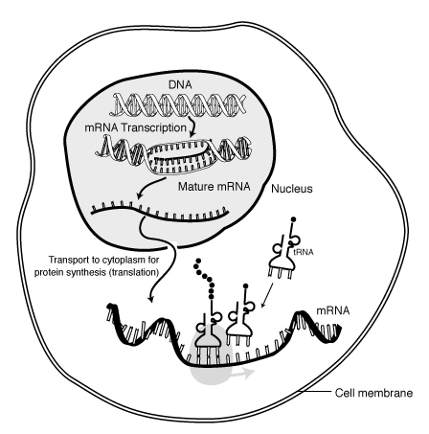

**Unit 5 Key Take-Aways**

* DNA 🡪 RNA 🡪 Protein 🡪 Trait
* Mutations change the DNA code, which can result in problems for the organism
* All of an organism’s cells have the same DNA; gene regulation decides what jobs they do!
* Biotechnology is an important science, but remains controversial
* Gel electrophoresis allows scientists to identify individuals, endangered species, and discover evolutionary relationships between organisms
* Biotechnology is an important science, but remains controversial
* Key biotechnologies include: Human Genome Project, bacterial transformation, and transgenic organisms

**Mastery Quiz #1: 3/12/13**

**Mastery Quiz #2: 3/15/13**

**Unit 5 Test: 3/19/13**

|  |  |  |
| --- | --- | --- |
| **Biotechnology** | **Human Genome Project**  **Biotechnology** | **Gene Therapy** |
| Vocabulary:  1.  2. | Vocabulary:  1.  2. | Vocabulary:  1.  2. |
| Write a definition for biotechnology. | What is it? | What is it? |
| What does it mean to manipulate organisms?  Why do you think humans would want to select the characteristics an organism has? | List the 3 goals of the HGP:  1.  2.  3. | What is the role of the virus in gene therapy?  Describe a positive benefit of gene therapy: |
| **Video Reflection** | **Video Reflection** | **Video Reflection** |
| 1. What is biotechnology?      1. All cells in our bodies have _______________ in the nucleus. 2. What is the goal of biotechnology? *to develop*… _________________________________   ____________________________________________ | 1. In what year did the human genome project start? __________ 2. How many base pairs were sequenced in the HGP? ____billion 3. Why did scientists want to read all of the human DNA? | 1. Corey could not see correctly because his _________ was mutated.   **U4-23**   1. So, now that Corey’s eye has the correct sequence of DNA, his eye can make the ____________________ it needs to see again. 2. What carried the gene that Corey was missing? |

|  |  |
| --- | --- |
| **Stem Cell Research** | **Cloning** |
| Vocabulary:  1.  2. | Vocabulary:  1.  2. |
| What are stem cells? | What is cloning? |
| What is the difference between adult and embryonic stem cells? | What is a positive benefit from cloning? |
| Why is stem cell research controversial? | What is a negative aspect of cloning? |
| **Video Reflection** | **Video Reflection** |
| 1. Where can stem cells be found? 2. What “jobs” do stem cells have? What are they being used for today? | 1. Why was Tracker such an exceptional dog? 2. How did the scientists clone the dog Tracker?   *Scientists took ________ from Tracker and…* |

**U4-24**

|  |  |
| --- | --- |
| **Transgenic Organisms** | **Gel Electrophoresis** |
| **Also known as**:   * Recombinant ____ technology, ______________ engineering, genetically modified organisms, genetically modified crops   **How does it work?**   * We take the _________ from __________ organism and insert them into the DNA of another organism   **Example**:  We take human genes that make _____________ and put them into a ________________ plasmid. Then the bacteria will make human insulin and we can use it for medical purposes! We can make a protein that our body is lacking! | **How does it work?**   * Cut DNA into ____________________ using **restriction enzymes** * Separate the fragments by _____________. * ________________ different people or organisms based on their fragments   **What is it used for?**   * Identify genetic diseases * Finding evolutionary _____________________ * Analyzing crime scenes   **Example**:  Compare the DNA bands on the gel below.  The blood stain was found at a crime scene.  Who’s blood is it?:  ________________________ |

**U4-25**

**Biotechnology Practice**

**U4-26**

dad 1

mom

baby

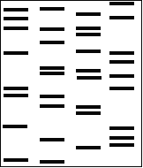

dad 2

**Practice!**

1. 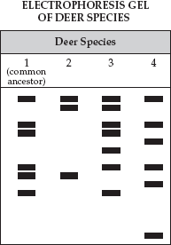Mrs. Smith (mom) has a baby named Jessica. She believes one of two men in this DNA fingerprint can be the father of her child. A paternity test is done and the results are shown above. Which of the 2 men are baby Jessica’s father? (hint: which father has the most bands in common with the baby?)
2. Which Deer Species is most closely related to the common ancestor (species 1)? ________ How do you know?

**Read each scenario presented below (in bold). Decide what YOU would do by circling the answer choice that best represents your view. Then, tell what type of biotechnology was given in the example.**

|  |
| --- |
| 1. **You've found out that the child you (or your wife) carries has the gene for dwarfism. A new therapy exists that may repair this gene before the child is born. What do you do?**  a. Allow the child to be born with the gene, and we will accept the child as is.  b. Attempt the new therapy to repair the gene  c. Terminate pregnancy. |
| Which of the 5 biotechnology topics does this apply to?  **Evidence:** |
| 1. **Pet cloning is now available at the local mall. You used to have a pet dog named Charlie, but he died two years ago. Now you learn that you can get a new Charlie by just bringing in a sample of his hair. What do you do?**  a. Find a strand of Charlie's hair as soon as possible. Can't wait to see Charlie again!  b. Leave your dog resting in peace; don't clone Charlie. |
| Which of the 5 biotechnology topics does this apply to?  **Evidence:** |
| 1. **Your family is known to have Huntington's disease. Huntington's is a disease that causes its victims to slowly lose their ability to speak, walk and function. Ultimately, Huntington's causes death. The symptoms do not usually appear until the person is in their forties. There is a test that will tell you whether you have the gene for Huntington's disease. What do you do?**  a. I would take the test, so that I would be better prepared for the future, and could make sure my family was taken care of.  b. I would not want to know. |
| Which of the 5 biotechnology topics does this apply to?  **Evidence:** |
| 1. **Cloning technology is perfected. A clone can be made from adult tissue samples. You learn that you need a kidney transplant, but there are no donors available. A doctor suggests that you make a clone of yourself, so that the kidney would be a perfect match. What do you do?**  a. One is enough of me, I'll wait for a donor.  b. Clone myself, two is better than one. |
| Which of the 5 biotechnology topics does this apply to?  **Evidence:** |
| 1. **An experimental procedure would allow you to add genes to your body. You can order certain genes, like a smart gene, or an athletic gene, or a musical ability gene. What do you do?**  a. We would have the procedure done, I'd like to be better in school and at sports.  b. We would not have the procedure done, people should accept themselves the way they are |
| Which of the 5 biotechnology topics does this apply to?  **Evidence:** |
| 1. **An insurance company is requiring individuals to get genetic testing performed to determine whether they have a higher risk of heart disease, cancer, or other diseases. They are requiring that all people wanting health insurance be tested. What do you do?**  a. find another insurance company, that information is none of their business  b. submit my DNA for a test, I'd like to know anyway.  c. file a lawsuit against the company |
| Which of the 5 biotechnology topics does this apply to?  **Evidence:** |