Name:________________________

Unit 2: Organic Molecules & Enzymes

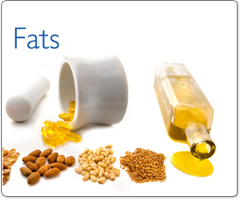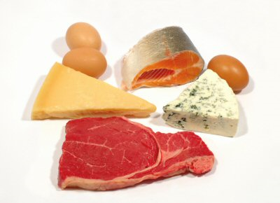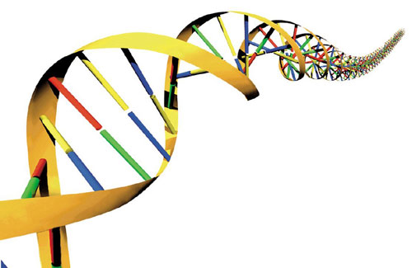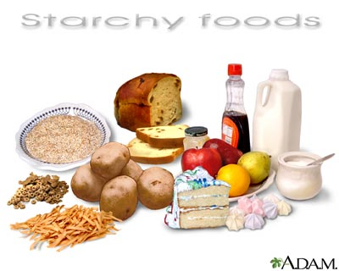

**Unit 2 Key Take-Aways:**

* There are 4 main organic molecules needed by **all** living organisms!
* Each molecule is made of smaller subunits (building blocks) and has a specific function.
* Enzymes are proteins with a specific shape that act as catalysts to speed up reactions, again & again.
* Enzymes can be denatured by temperature and pH.

**Vocabulary (Choose 5 to define):** acid, base, buffers, Carbohydrate, Lipid, Protein, Nucleic Acid, subunit, catalyst, enzyme, pH, molecule, organic, inorganic, reaction, denature, solute, solvent, solution, digestion, product, reactant, glycogen, cellulose, substrate, activation energy, monomer, polymer, polysaccharide, monosaccharide

**Mastery Quiz #1:**

**Mastery Quiz #2:**

**Unit 2 Test:**

pH Scale

**U2-1**

Solutions in which water is the Solvent can either be **Acidic**, Basic, or **neutral** depending on how many hydrogen ions (H+) or hydroxide ions (─OH) are present. All organisms need to maintain homeostasis with regards to their pH in order to remain living.

**Procedure:**

1. Make a prediction about each item: will it be acidic, basic, or neutral?
2. Measure the pH using pH paper
3. Record your findings in the table, then transfer them to the pH scale below

|  |  |  |
| --- | --- | --- |
| **Item** | **Prediction**  (acid, base, or neutral!?) | **Measured pH** |
| Milk |  |  |
| Bleach |  |  |
| Vinegar |  |  |
| Tap Water |  |  |
| Baking Soda |  |  |
| Diet Coke |  |  |
| Lemon Juice |  |  |
| Stomach Acid |  |  |

1. Draw and label a line on the pH scale below to show where each item fell on the scale!

|  |  |
| --- | --- |
|  |  |

**neutral**

(water)

0 1 2 3 4 5 6 7 8 9 10 11 12 13 14

**Strong Weak Weak Strong**

**Acidic**

**Basic**

**“Alkaline”**

BUFFERS: __________ pH and help keep pH levels ____________!

1. When a cell’s pH _________ (becomes more ___________) the buffers in the cell “____________” the hydrogen ions. Effect: cell becomes more ______________.
2. When a cell’s pH _________ (becomes more __________) the buffer in the cell “______________” the hydrogen ions. Effect: cell becomes more ____________.

**Analyzing Nutrition Labels:** Select 3 food items and analyze their nutrition labels. Record your findings below.

|  |  |  |  |  |  |  |
| --- | --- | --- | --- | --- | --- | --- |
| **Food Item** | **Total Calories** | **Total Fat** | **Total Carbohydrates** | **Total Protein** | **Does it have nucleic acids?** | **Is it healthy?** |
|  |  |  |  |  |  |  |
|  |  |  |  |  |  |  |
|  |  |  |  |  |  |  |

Organic Chemistry

**U2-2**

|  |  |
| --- | --- |
| **What is MATTER?** | * Matter is anything that takes up _________________ and has ______________ * All matter is made up of one or more ____________________. |
| **What is an ELEMENT?** | * Elements are found in nature as**____________** , **_____________**, or **_____________**. * Scientists have organized natural elements into a ___________________________. * Elements can take on different properties when they are bonded together with other elements to form ________________________. |
| **What are the 5 main elements that make up your body?** | 5 elements make up over 90% of your body!  _____, H, _____, O, _____  (Carbon, Hydrogen, Nitrogen, Oxygen, Phosphorous) |
| **What is a MOLECULE?** | * Molecules are combinations of 2 or more _________________________. |
| **Examples of MOLECULES:** | * **CO2** = 1 carbon + 2 oxygen * **NaCl** = 1 Sodium + 1 Chlorine (table salt) * **H2O2** = 2 Hydrogen + 2 Oxygen (hydrogen peroxide) |
| **What are the 2 types of MOLECULES?** | ______________________________ & ________________________________ |

|  |  |
| --- | --- |
| **ORGANIC MOLECULES** | **INORGANIC MOLECULES** |
| * Contain **________________,** hydrogenand **_________________** atoms together * Make up **________________** things * Molecules that play an important **role** in living things * Examples: * C6H12O6 (table sugar) * Vitamin B (C63H88CoN14O14P) * Methane (CH4) | * ______________ contain carbon, hydrogen and oxygen together * Make up **___________________________** things * Molecules that also play an important role in living things * Examples: * O3 (ozone) * Water (H2O) * Salt (NaCl) |

|  |  |
| --- | --- |
| **What is a MONOMER?**  **Example:** | * The _____________________________ unit of a substance (the building block) * Like the **BRICK** which will make the house * **MONO**saccharide = _________ sugar |
| **What is a POLYMER?**  **Example:** | * _____________________ monomers linked together to make a _________________ structure; also called a ________________________ (many repeating subunits linked together) * Like the **HOUSE** made up of bricks * **POLY**saccharide = __________ sugars |

Organic Molecule Project**:** Presentation due **_____________________ !**

**U2-4**

As part of the Chemistry of Life Unit, you have been given the job of advertiser for a company that sells organic molecules. You will be placed into a team of approximately 4 advertisers. Each group member will be assigned an organic molecule for which they will research information and create an advertisement. Each group will give its finished advertisements to the president of the company (your teacher). All group members MUST contribute equally to the project.

1. Complete Pre-Work on each molecule BEFORE beginning your project (pgs. U2-5 through U2-7).
2. Foldable will be due on presentation day
3. Create a 3-D model complete structural diagram of the organic compound. This model must be able to hang from the ceiling in our classroom and have the common name, at least two separately labeled subunits, and be colored using the legend. (Carbon=Red, Nitrogen=Green, Oxygen=Blue, Hydrogen=Yellow, Phosphorus=Orange)
4. Create a poster for your organic molecule.

**POSTERS MUST INCLUDE THE FOLLOWING INFORMATION**:

1. Name of the organic molecule

2. The primary elements that make up the organic molecule

3. Description of the organic molecule’s structure

4. Two examples of the organic molecule (Ex: Carbohydrates – Starch, Glycogen) (NOT FOODS)

5. Functions of the organic molecule

6. The test used to identify this molecule in a lab

7. At least 3 other pieces of information about the organic molecule

Possible areas to research:

An interesting fact about the organic molecule

A current event (news article) involving the molecule

Types of bonds that hold a molecule together

Types of bonds that hold multiple molecules to each other

Reactions involving the molecule, with food label

Products in which the organic molecule is found

Where is this organic molecule found in nature?

Industrial uses

1. Create and perfect your presentation for the president of the company explaining why your organic molecule would be the most popular if marketed to the public. Presentation must include and explanation of the structure, function, examples, and the test used to find it.
   1. Presentation may be done using a group explanation, skit, rap, song, PowerPoint presentation, or movie.
   2. Two minutes long.

Carbohydrates

**U2-5**

Starch vs. Simple Sugar

There are two main categories of carbohydrates: **simple sugars** and **starches**. **Glucose** is an example of a simple sugar. Starch is made from a chain of these glucose subunits.

**Starch**

**Glucose**

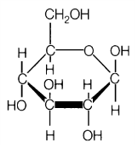



Draw a starch below

(“polysaccharide”)

Draw a simple sugar below

(“monosaccharide”)

Carbohydrate vs. Lipid

*Put the following words in the correct box: either Carb or Lipid!*

* Benedict’s Test
* Monosaccharide
* Glycerol
* Quick energy
* Long term energy
* Cellulose
* Glucose
* Brown Paper Bag Test
* Iodine Test
* Polysaccharide
* Starch

|  |  |
| --- | --- |
| **Carb** | **Lipid** |
|  |  |

**What should I eat?**

Carbohydrates and lipids store energy for different functions. Choose between simple sugars, starch, or lipids and tell me what I should I eat if . . .

1. I want to swim 50 miles (short term energy):
2. I want to run the100 meter dash (quick energy):
3. I want to prepare to live on a deserted island with little to no food (long term energy storage):

Nucleic Acids

**U2-6**

Draw a **nucleotide.**

Nucleic Acids are made up of ___________________ (the subunit, “building blocks”)

*Use page 47 in your textbook, to label your nucleotide using the following words*: **phosphate group, nitrogenous base, sugar.**

Protein

Draw a **protein.**

Proteins are made up of ___________ ___________ (the subunits, “building blocks”)

*Label your protein using the following words*: **amino acid, peptide bond, polypeptide.**

**Famous examples of proteins**

Insulin &Hemoglobin are two very important proteins found in your body. Use pages 1007 and 952 to answer the following questions.

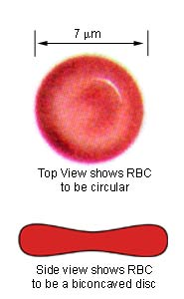

1. What is the job of **insulin** in the body?
2. Where can I find **insulin**?
3. What is the job of **hemoglobin** in the body?
4. Where can I find **hemoglobin**?

Which Organic Molecule?!

**U2-7**

*Sort the following words as carbohydrates, lipids, proteins, or nucleic acids in the chart below:*

|  |  |
| --- | --- |
| **Carbohydrates** | **Lipids** |
|  |  |
| **Proteins** | **Nucleic Acids** |
|  |  |

* Iodine
* Benedict’s
* No test
* Fatty acids
* Nucleotide
* Sugars and starch
* Amino acids
* Control genes
* Brown paper bag
* Starch
* Glucose
* Enzymes
* Stored energy
* Controls body functions
* Quick energy
* Biuret’s
* Long term energy
* Hormones
* Glycerol
* Nitrogen
* Phosphorus

**Organic Molecules Foldable**

You will create a “foldable” with 4 doors to organize all of the information about the four organic molecules. You must include:

* **Monomers (subunits)**
* **Which test will show their presence**
* **Function**
* **Drawing of the molecule**
* **Non-food examples of the molecule**

Carbohydrates

Proteins

Lipids

Nucleic Acids

**\*\*\*Each group member must complete this sheet and turn it in with their poster:**

**U2-8**

Name of the organic molecule: ______________________________________________________________________

The main elements that make up the organic molecule:

Description of the organic molecule’s structure:

Two examples of the organic molecule: ______________________________________________________________

______________________________________________________________

Functions of the organic molecule:

Extra Information:

3.

2.

1.

Sources:

Your project will be out of 60 points: 20 points for the structure, 20 points for the poster, 10 points for the presentation, and 10 points for correct names and examples using the following rubric:

**U2-9**

|  |  |  |  |  |  |
| --- | --- | --- | --- | --- | --- |
|  | Unsatisfactory  (0-50%) | Satisfactory  (50-65%) | Average  (65-79%) | Exemplary  (80-100%) | Mark |
| Name and examples | Many glaring errors, cannot name examples    **≤ 5** | Includes incorrect or mismatched examples    **7** | Includes 1 correct out of 2 required examples    **8** | Correct delivery of name and 2 examples of the molecules  **10** | **/10** |
| 3-D model (complete structural diagram) | Incorrectly constructed, unattractive, confusing, and/or contains incorrect information  **≤ 10** | Correct skeleton model, but incomplete  **10-13** | Well constructed, clearly displayed, and contains correct information with a legend  **13-16** | The model is complete, and reflects substantial effort having been made with attention bonding elements  **16-20** | **/20** |
| Poster | A very limited or absent address of molecule’s risks/benefits, uses, or special facts of compound  **≤ 10** | Addresses miscellaneous risks/benefits, uses, or special facts of the molecule  **10-13** | Addresses significant amount of risks/benefits, uses, and special facts of compound  **13-16** | Presents a detailed and logical analysis of risks/benefits, uses, or special facts of compounds and is able to back up analysis with chemistry concepts  **16-20** | **/20** |
| Presentation | Delivery is poor, thus showing the presenters do not know their information very well  **≤ 5** | Delivery is inconsistent in quality with some strong and weak areas  **5-6.5** | Delivery is well done, with minor, predictable mistakes  **6.5-8** | Delivery is well done in a confident, relaxed, clear, and concise manner.  **8-10** | **/10** |

Comments:

**U2-7**

Organic Molecules Testing Lab

Background**:** The foods you eat are made of organic compounds. You can perform chemical tests to learn what foods contain carbohydrates, lipids, and/or proteins.

Directions**:** You will move to 3 different stations during the block. You must visit all 3 stations and complete all tests to receive the full credit. You will complete the chart on page U2-11 to organize your results.

At each station you will test 3 mystery solutions for the presence of proteins, starch, or lipids. Ms. Simmons will demonstrate the Benedict’s test at her lab bench.

Station 1:

**Brown Paper Bag-** a test for lipids. Lipids will cause the bag to appear oily with a clear stain on the bag, like a greasy Mc. Donald’s bag.

1. Check the box that would produce a **positive Brown Paper Bag** test result:

* Simple sugar
* Starch
* Protein
* Lipid
* Nucleic acid

1. Add 6 drops of your mystery solutions to 3 separate spots on the bag. Label each spot to prevent confusion.
2. After 1 minute, dab any excess liquid from bag with a paper towel. Note any change. If lipid is present the solution will leave an oily clear residue on the bag, depending on lipid concentration.

Station 2:

**Iodine Solution**- a test for starch. Starches will cause the iodine to turn dark purple/black.

1. Check the box that would produce a positive Iodine test result:

* Simple sugar
* Starch
* Protein
* Lipid
* Nucleic acid

1. Add 2mL of your mystery solutions to 3 separate test tubes labeled A, B, and C.
2. Add 5-10 drops of the iodine solution to each test tube.
3. Shake the test tube very gently.
4. Note any color change. Starch will turn a dark blue, purple or black color.

Station 3:

**Biuret’s Reagent**- a test for proteins. Proteins will cause the Biuret’s to turn violet or purple.

1. Check the box that would produce a positive Biuret’s test result:

* Simple sugar
* Starch
* Protein
* Lipid
* Nucleic acid

1. Add 2mL of your mystery solutions to 3 separate test tubes labeled A, B, and C.
2. Add 5-9 drops of Biuret’s Reagent solution.
3. Shake the test tube very gently.
4. Note any color change. If proteins are present, the solution will turn violet or purple.

Results: *Briefly* ***describe*** *what you see at each station:*

**U2-8**

|  |  |  |  |  |
| --- | --- | --- | --- | --- |
| **Mystery Solution** | **Iodine** | **Biuret’s Reagent** | **Brown Paper Bag** | **Benedict’s**  **Solution** |
| Will turn dark purple/black if **starch** is present | Will turn violet or purple if **proteins** present | Will leave a grease spot if **lipids** are present | Will turn anywhere from orange to red if **sugar** is present |
| **A** | Color: ____________  starch present? ___ | Color: ____________  proteins present? ___ | Grease spot: ____________  lipids present? ___ | Color: ____________  simple sugar present? ___ |
| **B** | Color: ____________  starch present? ___ | Color: ____________  proteins present? ___ | Grease spot: ____________  lipids present? ___ | Color: ____________  simple sugar present? ___ |
| **C** | Color: ____________  starch present? ___ | Color: ____________  proteins present? ___ | Grease spot: ____________  lipids present? ___ | Color: ____________  simple sugar present? ___ |

Analysis Questions:

1. Which mystery solutions contain **starches**? How can you tell?
2. Which mystery solutions contain **simple sugars**? How can you tell?
3. Which mystery solutions contain **proteins**? How can you tell?
4. Which mystery solutions contain **lipids**? How can you tell?
5. Which mystery solutions contain **nucleic acids**? How can you tell? *Check your notes if you aren’t sure!*
6. What 2 elements do carbohydrates, proteins, lipids, and nucleic acids have in common? Why?!
7. If you are trying to build muscle, which of the materials tested should you eat a lot of?
8. If you are trying to lose weight, which of the materials tested should you reduce in your diet? (not eat as much)
9. Which of the materials contain *genetic information*? Explain.

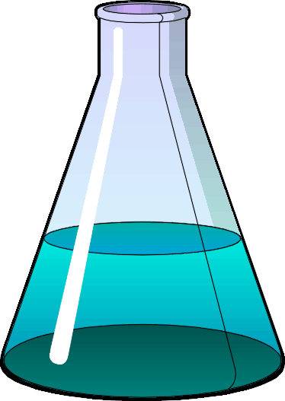Chemical Reactions

**U2-12**

In science we use specific vocabulary for chemical reactions:

**______________🡪____________**

2 Types of Chemical Reactions:

Digestion (decomposition):

“________________________”

Synthesis

“________________________”

+

+

**→**

**→**

Practice!

1. Circle the **reactants** below:   
    nucleotide + nucleotide + nucleotide 🡪 DNA (nucleic acid)
2. Circle the **products** below:

nucleotide + nucleotide + nucleotide 🡪 DNA (nucleic acid)

1. **Synthesis:** Hershey’s syrup + milk 🡪 ___________________
2. **Digestion:** chocolate milk 🡪 _____________________ + ________________
3. **Synthesis:** glucose +glucose + glucose + glucose 🡪 _________________
4. **Digestion:** starch 🡪______________ + ______________ + ______________ + ______________
5. **Synthesis:** fatty acids + glycerol 🡪 _________________
6. **Digestion:** lipid 🡪 __________________ + ________________
7. **Synthesis:** amino acid + amino acid + amino acid 🡪 ___________________
8. **Digestion:** protein/polypeptide 🡪 ____________________ + ______________________ + _________________
9. **Digestion:** carbohydrate 🡪___________________+ __________________ + __________________

Enzymes

**U2-13**

**Enzymes** help increase the ______ of reaction (the speed of the reaction)

ex: starch

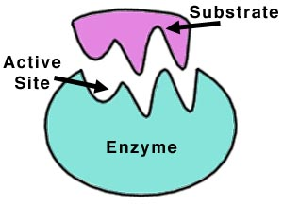

1. **Enzymes are _____________________:** They are made of amino acids.
2. **Enzymes are ___________________:** They speed up reactions.
3. **Enzymes are _____________________:** Shape matters! They work with only 1 ____________

* If you __________________ an enzyme by changing the _______________ or ____, you change its shape and it no longer works!

1. **Enzymes are ___________________:** They can be used again and again!
2. **Enzymes** ___________ the ___________________ energy which is the _________ needed for a reaction to occur.
3. **Enzymes help with _________________ & _________________!!!**

Practice! – what happens when we add an enzyme?!

1. Circle the **reactants** below:   
    nucleotide + nucleotide + nucleotide + enzyme 🡪 DNA (nucleic acid) + enzyme
2. Circle the **products** below:

nucleotide + nucleotide + nucleotide + enzyme 🡪 DNA (nucleic acid) + enzyme

1. **Synthesis:** Hershey’s syrup + milk + enzyme 🡪 ___________________ + ________________
2. **Digestion:** chocolate milk +enzyme 🡪 _____________________ + ________________+ ________________
3. **Synthesis:** glucose +glucose + glucose + glucose + enzyme 🡪 _________________+ ________________
4. **Digestion:** starch + enzyme 🡪 ______________ + ______________ + ______________ + ______________
5. **Synthesis:** fatty acids + glycerol + enzyme 🡪 _________________+ ________________
6. **Digestion:** lipid + lipase 🡪 __________________ + ________________ + ________________
7. **Synthesis:** amino acid + amino acid + amino acid + enzyme🡪 ___________________+ ________________
8. **Digestion:** protein + protease🡪 ___________________ + _________________ + ________________+ __________

Enzyme Reaction Rate Graph

**Optimum** pH or temperature = **BEST** pH or temperature

**U2-14**

This graph shows the **optimum pH** for enzyme

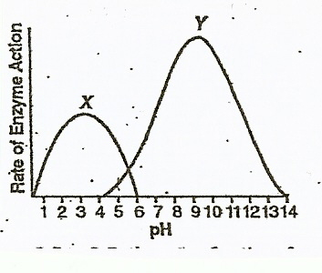X and enzyme Y.

1. Enzyme X works the best at a pH of _____ - that is its **optimum pH!**
2. Enzyme Y works the best at a pH of _____ - that is its **optimum pH!**
3. What range of pH is bad for enzyme X? Where does it work the slowest (or not at all?!)
4. When enzyme X is placed in an environment where its pH is 9, what happens to enzyme X’s shape?
5. At what pH does enzyme Y **denature**? How can you tell based on the graph?

Enzyme Reaction Diagram

Label the following:

* Enzyme
* Substrate
* Product
* Enzyme-substrate complex
* Reactants

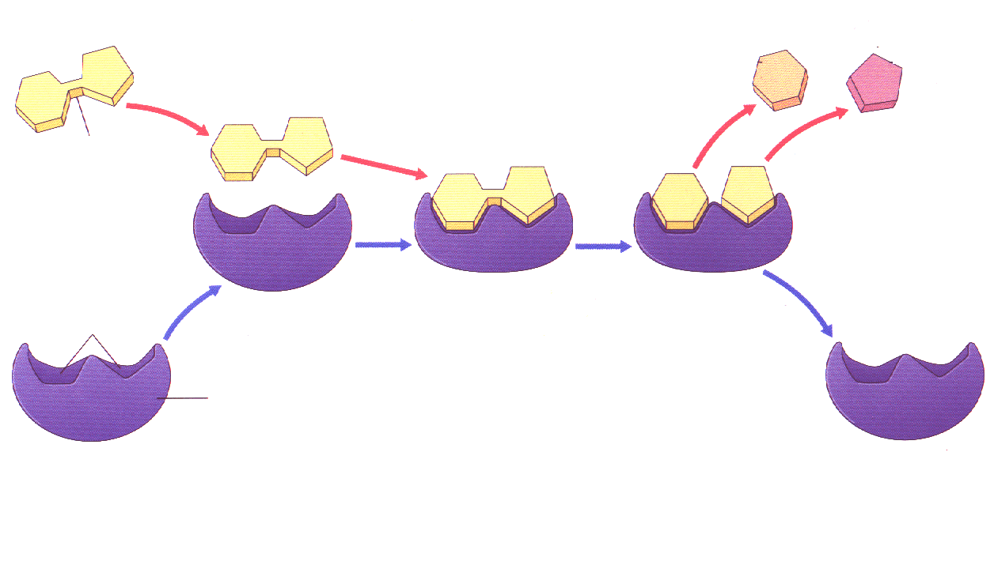

1. Adippose is changed into putilip by tiggase.

**U2-14**

Enzyme

Substrates: _____________________________

Products: ___________________

1. The breakdown of a hulgose into yelipose and betilose is accomplished by retase.

Enzyme:

Substrates:

Products:

1. Acetylcholinesterase breaks down acetylcholine into acetyl and choline.

Enzyme:

Substrates:

Products:

1. A disaccharide can be broken down into glucose and fructose by lysozyme

Enzyme:

Substrates:

Products: __________________________________________________________________________________________

**True or False:** Decide whether the statement is true or false. If false, **re-write** the sentence to make it true.

_____ 1. Enzymes can work with a wide variety of substrates, because they have a general shape

_____ 2. Enzymes can be denatured by the wrong temperature and pH.

_____ 3. Enzymes can only be used once in a reaction.

____ 4. Enzymes are made of building blocks called nucleic acids.

_____ 5. Enzymes speed up reactions by lowering the activation energy

Station 1: Enzymes and Temperature

Procedure:

1. Label three depressions A, B, C
2. Place **SIX** drops of iced yeast solution in depression A.
3. Place **SIX** drops of room temperature yeast solution in depression B.
4. Place **SIX** drops of boiled yeast solution in depression C.
5. Now quickly place about **3** drops of H2O2 in depression A.
6. Carefully observe the depression.
7. Record the reaction time and bubble rating.
8. If the reaction lasts longer than 1 minute, write “>1”.
9. Repeat steps 5-8 for depression B and then for depression C.

Data Table 1

|  |  |  |
| --- | --- | --- |
| Depression | Complete Time for reaction | Bubble Rating (0-10) |
| A. iced |  |  |
| B. room temp. |  |  |
| C. boiled |  |  |

Bar Graph 1: Graph the Bubble Rating for each solution

10

9

8

**Enzyme Activity**

7

6

5

4

3

2

1

iced room boiled

**Temperature**

Station 2: Enzymes and pH

Procedure:

1. Label three depressions A, B, C
2. Place **FOUR** drops of room temp yeast solution in depression A, B, C.
3. Place **TWO** drops of vinegar (acid) in depression A.
4. Place **TWO** drops of water in depression B.
5. Place **TWO** drops of baking soda water (base) in depression C.
6. Now quickly place about **3** drops of H2O2 in depression A.
7. Carefully observe the depression.
8. Record the reaction time and bubble rating.
9. If the reaction lasts longer than 1 minute, write “>1”.
10. Repeat steps 6-8 for depression B and then for depression C.

Data Table 2

|  |  |  |
| --- | --- | --- |
| Depression | Complete Time for reaction | Bubble Rating (0-10) |
| A. acid |  |  |
| B. neutral |  |  |
| C. base |  |  |

Bar Graph 2: Graph the Bubble Rating for each solution

10

9

8

**Enzyme Activity**

7

6

5

4

3

2

**U2-15**

1

acid neutral base

**pH**

Station 3: Enzymes are Specific

Procedure:

1. Label two depressions A, B.
2. Place **SIX** drops of room temp yeast solution in depression A.
3. Place **SIX** drops of Lactase solution in depression B.
4. Now quickly place **3** drops of H2O2 in depression A.
5. Record the reaction time and bubble rating.
6. If the reaction lasts longer than 1 minute, write “>1”.
7. Repeat steps 4-6 for depression B.

Data Table 3

|  |  |  |
| --- | --- | --- |
| Depression | Complete Time for reaction | Bubble Rating (0-10) |
| A. catalase |  |  |
| B. lactase |  |  |

Bar Graph 3: Graph the Bubble Rating for each solution

10

9

8

**Enzyme Activity**

7

6

5

4

3

2

1

catalase lactase

**Enzyme**

Station 4: Enzymes are Reusable

Procedure:

1. Place a small piece of avocado into a test tube.
2. Place **EIGHT** drops of H2O2 onto the avocado.
3. Record reaction time and bubble rating.
4. Drain ONLY the water from tube! Use the SAME piece of avocado!
5. Repeat steps 2-5 for Trial 2.
6. Repeat steps 2-5 for Trial 3.

*\*****NOTE****: The liquid that drains off is H2O. The enzyme in the avocado broke the H2O2 (the substrate) into H2O and oxygen (the products).*

Data Table 4

|  |  |  |
| --- | --- | --- |
| Depression | Complete Time for reaction | Bubble Rating (0-10) |
| A. 1st trial |  |  |
| B. 2nd trial |  |  |
| C. 3rd trial |  |  |

Bar Graph 4: Graph the Bubble Rating for each solution

10

9

8

**Enzyme Activity**

7

6

5

4

3

2

**U2-16**

1

1st trial 2nd trial 3rd trial

**Trial**

Enzyme Lab Conclusion Questions

**U2-17**

**You tested the enzyme** catalase**. This enzyme is found in yeast cells and many other cells (including avocado). The chemical reaction that it speeds up is as follows:**

**H2O2🡪 H2O + O2**

***Directions****: Write your answers* ***IN COMPLETE SENTENCES.***

1. What is the relationship between **temperature** and **enzyme activity**? Use evidence from your experiments to support your statement.
2. What happens to enzyme molecules in extreme temperatures? Use evidence from your experiment.
3. What might happen to a human being if a **fever** gets too high? (Hint: there are enzymes (proteins) in our bodies).
4. What is the relationship between **pH** and **enzyme activity**? Use evidence from your experiments to support your statement.
5. Stomach enzymes work best at a pH of 2. In other words, this is their “optimal pH”. How might a pH of 10 in the stomach affect digestion?
6. Which substance is reusable: the substrate (H2O2) or the enzyme (catalase) in the liver? **Use evidence from Station 4 to support your statement.**
7. What does the phrase “lock and key” mean when talking about enzymes? Which station (1, 2, 3, or 4), demonstrated the “lock and key” characteristic of enzymes?
8. What type of organic molecule is an enzyme? What are its building blocks (subunits, monomers)?
9. What are ways an enzyme can be **denatured**? If an enzyme is denatured, why will it not work anymore?

10 . At station 3, which solution had a higher bubble rating (yeast or lactase)? Why didn’t the enzyme lactase break down the H2O2?

Unit 2 Study Guide

**U2-19**

**Enzyme Practice**

*Answer the following questions using the graph to the right.*

1. At which pH levels, will enzyme X denature? ___________

2. What is the optimum pH of enzyme X? ___________

3. At which pH levels will enzyme Y denature? _____________

4. What is the optimum pH of enzyme Y? _____________

5. Does enzyme X work best under acidic or basic conditions?

6. Does enzyme Y work best under acidic or basic conditions?

**Enzymes Sugars**

7. True or False: Enzymes are proteins.

Sucr**ose**

Fruct**ose**

Galact**ose**

Lact**ose**

Sucr**ase**

Fruct**ase**

Galact**ase**

Lact**ase**

8. What three letters do enzymes often end with?

9. What does is mean for enzymes to be specific?

10. What does it mean for enzymes to be “reusable?”

11. Explain what happens to an enzyme if its environment becomes too hot.

**Matching**.

*Pair the word with the correct definition*

______ 1. Organic A. Used for stored energy and cell membranes; made of fatty acids

______ 2.Inorganic B. A type of protein that regulates the amount of sugar in the blood

______ 3.Carbohydrate C. A word meaning “best” or “ideal”

______ 4.Lipids D. The type of starch found in plants

______ 5. Protein E. Contains one or no carbon atoms; compose non-living things

______ 6.Nucleic Acids F. When an enzyme no longer works because its shape is wrong

______ 7.Amino acid G. A type of protein that transports oxygen in the blood

______ 8. Cellulose H. Contains multiple carbon molecules; compose living things

______ 9.Enzyme I. The building blocks of proteins

______ 10. Substrate J. Used for quick energy; made of sugars and starches

______ 11. Optimum K. Used for nearly all functions in the body; made of amino acids

______ 12.Insulin L. A molecule that speeds up reactions

______ 13.Hemoglobin M. A biological catalyst that is a protein; shape matters!

______ 14. Denatured N. Store genetic information; made of nucleotides

______ 15.Catalyst O. Also called a reactant; binds with an enzyme in reactions

*What color change would we expect with a positive result for the following tests?*

**Benedict’s:**

**Biuret’s:**

**Iodine:**

**Brown paper bag:**

**The Tests:** *Match the tests with the organic molecules they identify*!

______ Benedict’s Solution A. Nucleic Acids

______ Biuret’s Reagent B. Proteins

______ Iodine Solution C. Sugars

______ Brown paper bag test D. Starches

______ No test- in all living organisms E. Lipids

**Enzyme Graphs**

**U2-20**

Temperature Temperature Acid Base Acid Base

(a) (b) (c) (d)

Enzyme Efficiency

* 1. Graph (a) shows that this enzyme will work best at what type of temperatures?
  2. Graph (b) shows that this enzyme will work best at what type of temperatures?
  3. Graph (c) shows that this enzyme will work best at what type of pH?
  4. Graph (d) shows that this enzyme will work best at what type of pH?

**Organic Molecules**

**\*Be able to identify pictures of all 4 organic molecules\***

**Label the 3 parts of the nucleotide below:**

1. Nitrogenous base
2. Sugar (glucose)
3. Phosphate group

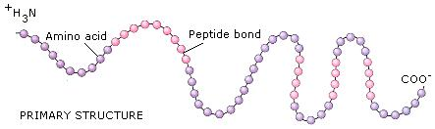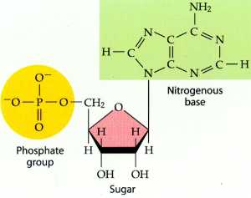

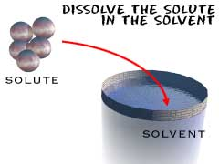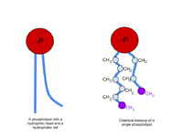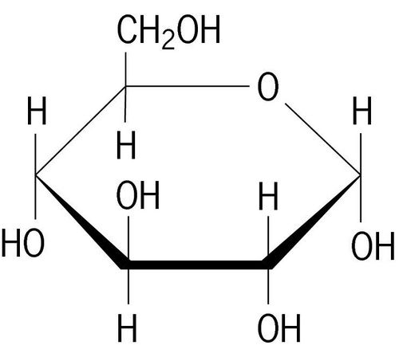

**The __________ gets dissolved in the ____________ to make a _____________.**

Ex. Chocolate is the solute because it is dissolved in regular milk (solvent) to make a solution of chocolate milk

1. What is the characteristic of an organic molecule?
2. Is carbon dioxide (CO2) an organic molecule? Why or why not?