Honors Forensics Final Project
Objective: create a movie (can be modeled after CSI, First 48, Forensic Files, The New Detectives etc.) to demonstrate your knowledge of forensic science. For this project, your crime may be imagined or based on cases we have studied in class. You will present the project to the class during Exams.
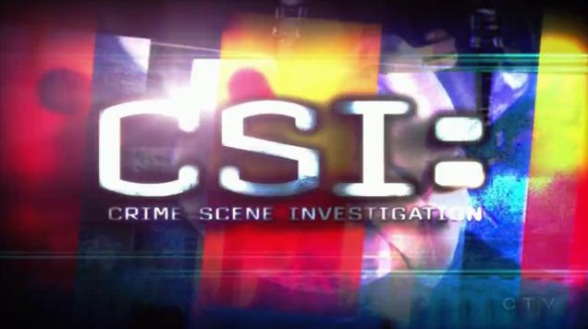

Guidelines:
Videos must be a minimum of 10 minutes in length
Videos must include 5 units from class (Unit 1, 3 units of your choice and 1 extra unit)
All group members must take on a role AND appear in the movie

Stage One: Outlining and Editing
Outline Due: November 8, 2016 B- Day November 9, A - Day
Script Due: November 21, 2016 B- Day November 22, A - Day

Stage Two: Production
Storyboard Due: February 9, 2016 B – Day, February 10, 2016 A – Day
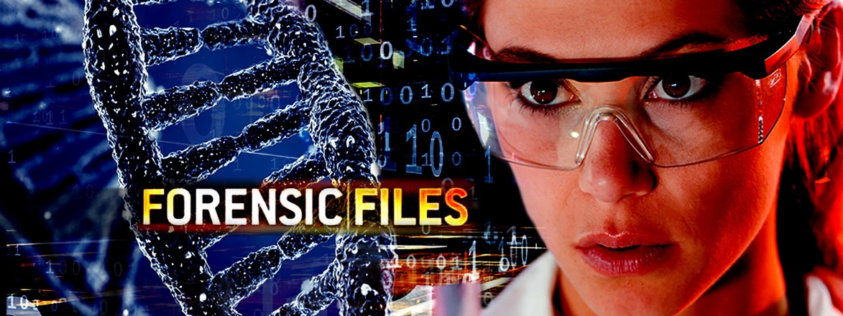

Stage Three: Editing
Rough Draft – April 5, 2016 B –Day, April 6, 2016 A – Day

Final Stage
Project Due: May 11, 2016 B - Day, May 12, 2016 A - Day

