In the 1830’s, ____________ _____________________ developed one of the first tests for ___________________ after being called to testify in the trial of James Brodie accused of poisoning his grandfather by poisoning his coffee.
Brodie was acquitted because of reasonable doubt. Why?

Marsh refined his test for arsenic. Describe his refined test.

Karl Landsteiner led the way for _________to be used as a testing sample.

Forensic toxicology is the branch of forensics that performs testing and analysis for drugs or chemicals that may be related to or found at a crime scene. Common samples used for testing include:

In the U.S. , an estimated 75% of evidence obtained by law enforcement is drug related. Some drugs can be identified visually:
a.
b.

Video notes:

Drug screen:

Compound identification:

Why is it important to know the exact substance and specific amount of a drug in the possession of a person when arrested or searched?

Qualitative test:

Quantitative test:

Video notes:

Drug Testing
There are commercially available screening tests that allow law enforcement to conduct presumptive tests in the field. These screening kits have advantages and disadvantages.
Advantages of screening kits:
- Can be done at the crime scene
- Gives quick initial identification of a particular substance
- Assists investigators to make a decision about further testing or arrest at the scene
- Reduces the laboratory work load and number of samples sent to the lab
- Saves money because only positive tests must be sent to lab for confirmatory tests
- Can be used to rule out substances
Disadvantages of screening kits:
- False positive results can be registered if there are interfering substances
- Must know what drug you want to test for because the kits are specific for a particular drug. Example: a screening kit that tests for cocaine will not detect barbituates.
Presumptive tests rely on interpreting a ________________ change (colorimetric test). Presumptive tests can be done directly on the substance or indirectly on blood, urine, saliva or other body fluids.
Advantages of presumptive tests:
- Highly sensitive
- No expensive equipment
- Kits are portable.
- Many use sulfuric acid which reacts with the unknown to produce the color change which is read against a reference color chart.
- Some tests rely on specific odors produced such as the test for cocaine which produces a _________________ or __________________ smell.
Type of Test | Positive Result (color)
Marquis color test | Purple: heroine, morphine, opiates  Orange-brown: amphetamines
Cobalt thiocyanate | Blue: cocaine
Dillie-koppanyi | Violet-blue: barbituates
Duquenois-Levine | Blue-purple: LSD
Van Urk | Blue-purple: LSD

Confirmatory tests are used to confirm a ___________________ result from a presumptive test and accurately identify substances so that drug evidence can be admissible in court.
Advantages of confirmatory tests:
- More specific
- Accurate
- Less risk of false positive results
Disadvantages of confirmatory tests:
- Expensive equipment is needed
- Requires a forensic drug chemist to analyze the results produced by the machine

Confirmatory testing methods:
- Gas Chromatography-Mass Spectrometry (GC-MS)
The gas chromatograph reduces the structure of the chemical compound to individual molecules based on chemical properties. The molecules travel through a column and take different amounts of time to exit allowing the mass spectrometer to capture and detect each individual molecule. The GC produces fragments and the MS classifies the chemical compounds. It creates a ratio with its mass and electrical charge called the mass-to-charge ratio.

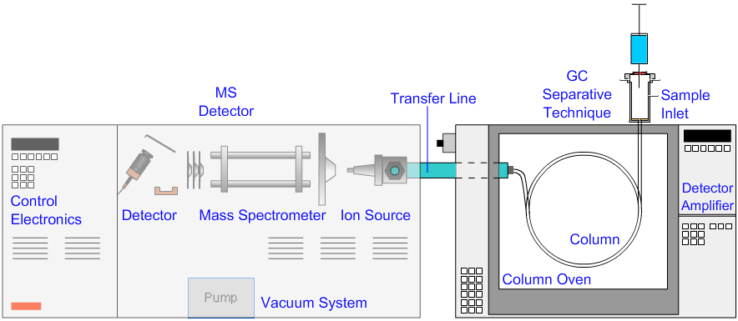
(www.chromacademy.com)
- Ultraviolet Spectrophotometry
Similar to GC-MS, this method uses the detection of light being reflected by the main elements of a compound to identify the compound. The results are analyzed and compared to a known sample range to identify the unknown drug.

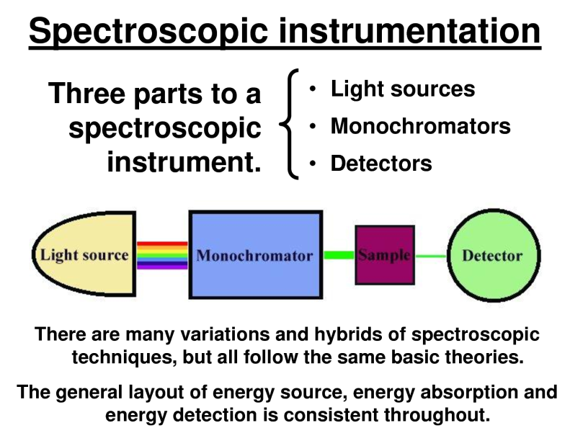

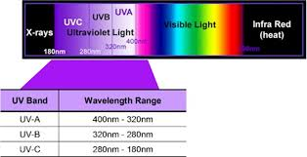

Quality Assurance
Testing methods must be accurate and produce expected results with known control samples that are positive and negative for the given drug. Control samples ensure that the machine is working properly and the test is valid. If the control samples don’t produce the expected results then the test is “invalid”.
Testing laboratories must follow procedures as written in the standard procedure manuals. Only one sample should be tested at a time to avoid mixing up evidence samples and compromising admissibility.
Always maintain the chain of custody!!.
Common illegal substances:
- Marijuana: one of the most widely used hallucinogens; Tetrahydrocannabinal or THC is the active ingredient that ranges from 1-20% (in the female flower)
Notes from student presentations:

- Cocaine: stimulant made from the coca plant grown in the Amazon. To produce one pound of cocaine, 500 pounds of the plant is needed. Most is made into a powder and snorted or crystallized and heated into vapors to be inhaled (crack). Cocaine acts on the central nervous system to produce alertness and energy. It decreases the appetite and need for sleep.
Notes from student presentations:

- Methamphetamine: Highly dangerous drug that induces feelings of euphoria. It can be injected, snorted, smoked and ingested orally. In controlled doses it is used to treat ADHD, obesity and narcolepsy. Meth addicts develop a condition called “meth mouth” because they don’t get dental care and use the money for the habit. They also develop sensations of bugs crawling under the skin causing them to scratch the skin and develop sores.
Notes from Student presentations:

- Opioids (opium based drugs): derived from the seed of the opium poppy plant. Widely used as a pain killer prescribed by physicians. Acts on the neuron receptors in the brain and spinal cord to block pain signals. Examples include Vicodin, Lortab, morphine, and some cough medicines.
Notes from student presentations:

- Alcohol: product produced from the fermentation of grains and fruits. In 2010, alcohol was a factor in over 31% of traffic deaths.
Field sobriety tests:

These tests do no quantify the amount of alcohol nor do they confirm that a driver or intoxicant is over the legal limit.

Portable breathalyzers: instrument that is able to quantify the amount of alcohol in the suspect’s blood by calculating the alcohol content of the “breath” blown into the device.
A confirmatory test (usually a blood or urine alcohol test) is done following chain of custody in order to be admitted into court.

Alcohol gets absorbed from the ___________________ and _________________________ into the bloodstream. Some alcohol gets broken down in the stomach due to an ____________________ present in the stomach acid. Males tend to produce more of this enzyme than females. As a result, males tend to be able to consume more alcohol than females before the results of intoxication are felt.
Alcohol is not chemically changed in the bloodstream. As blood passes through the lungs, some of the ingested alcohol moves across the membranes of the lung air sacs into the air and evaporates. The concentration of alcohol in the lungs to concentration in the blood is 1:2100.

Legal limits:
American Medical Association: a person can be come impaired when BAC hits 0.05 which means that there is 0.05 grams of alcohol per 100 ml of blood.
All 50 states have 0.08 as the legal limit with even lower limit for truck drivers and persons under 21. North Carolina has a zero tolerance law where anyone under 21 cannot register a BAC over 0.00.

Testing Devices:
  - Fuel Cell Method: chemical reaction generates an ______________________ signal in response to the breakdown of alcohol in the fuel cell. Fuel cell converts alcohol and water to acetic acid, H+ ions, and electrons at the anode. At the cathode, H+ and electrons combine with oxygen to regenerate water. This produces a flow of electrons from the anode to the cathode. The flow is measured and signal is displayed.
The higher the alcohol level= more electrons produced = more flow=more signal

Video notes:

  - Infrared Spectroscopy: based on the premise that all compounds absorb some infrared radiation at particular ________________________________because of their chemical bond arrangement. The infrared spectrum of an unknown is compared to the spectra results of a known compounds to identify the unknown.

Factors affecting alcohol tests:
- Drinking on an empty stomach (faster metabolism and absorption)
- Drinking with a fever (false positive result)
- Using mouthwash or breath spray (false positive0
- Nyquil
- No good way to spoof the system.
Video notes:

