Essential Standard: Understand the characteristics of fingerprints that allow them to be systematically classified.

- Early Classification
- Francis Galton (1892):
- outlined the ________of fingerprints in a text called Fingerprints
- suggested methods of recording prints
- proposed 3 pattern types:

  - .

- Chinese used prints as legal signatures
- Henry Fauld
  - suggest that fingerprints be used as personal identification
D. Sir Edward Richard Henry:
- developed the classification system used by most English speaking countries
- Dr. Juan Vucetich: developed a classification system used mainly in Spanish speaking countries

- Admissibility in Court:
1999: United States v. _________________
Defense argument: ____________________________________________________________________________________________________________________________________________________________
Judges Ruling:
- ________________________________________________________
- ________________________________________________________

- Individuality:
- general shape and pattern
- ___________ ______________ give additional individuality
- For a two prints to be a match the characteristics must be identical with the same relative_____________as determined by an expert.

IV. Principles of Fingerprints:

- Fingerprints are an _________________characteristic. No two fingers have yet been found to possess identical ______________characteristics.
- Probability of someone having the exact fingerprint as another person: __________________________________________________________________

- A fingerprint remains _______________ during an individual’s lifetime.
- reproductions of the skin ridges on the palm side of the _________ and _______.
- formed before birth at about _____________weeks gestation (in utero).
- created between the layers of the epidermis; hands and feet have an extra layer of epidermis
- stress from varying growth rates and constraints of the layers of the dermis cause the basement membrane (stratum basale) to buckle forming ridges and ridge patterns. ______________________forms a boundary to create ridge.
- _______________________that match is sufficient to meet criteria of individuality.

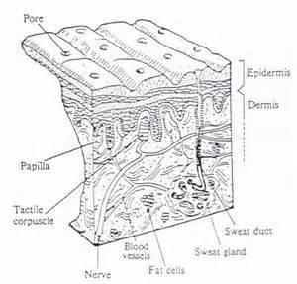

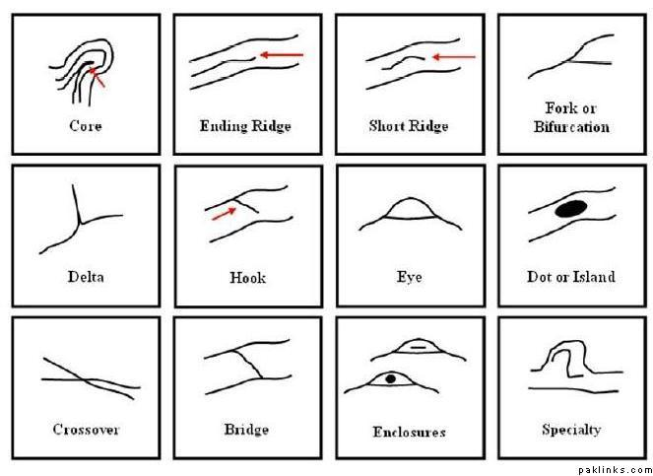

Can fingerprints be changed? If so how?

- Fingerprints have ridge patterns that allow them to be systematically classified.

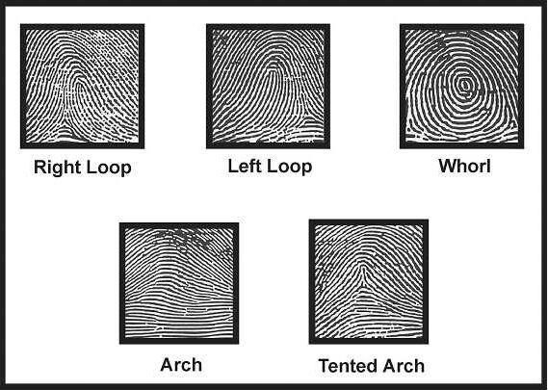
- Loops:
  - Must have one or more _____________ entering from one side of the print, recurving, and exiting from the side of entry
  - Loops have a core (center of the pattern) and one delta
  - 60-65% of the population has loops
  - ulnar loop: ___________________________
  - radial loop: __________________________
  - delta: ______________________________

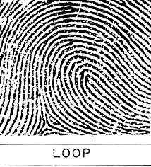
- Whorls
  - ______________appearance
  - must have at least two _____________and type lines
  - a plain whorl and a central pocket loop have at least one ridge that makes a complete circuit
  - ____________________of population have whorls
  - very common pattern especially on the ________________
  - 4 types of whorls: central pocket loop whorls, plain whorls, accidental whorls

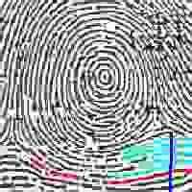

- Arches
  - _____________ of the population has arches
  - ridge lines enter from one side and flow out the other side forming a wavelike pattern
  - Arches do not have deltas or cores.
  - most simple print but also uncommon
  - Plain:
  - Tented:
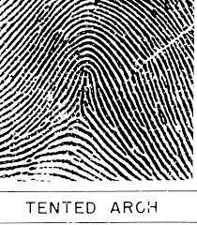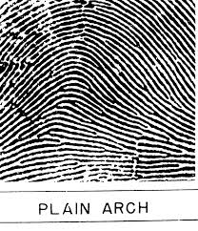

- Henry Classification System

- uses loops, whorls and arches approach
- categorizes ten-print fingerprints into one of these groups
- Assigns a number value to each finger based on the presence of a _________________
- results represent a ratio of odd/even fingers

right hand left hand
 | thumb | index | middle | ring | pinky | thumb | index | middle | ring | pinky
no. (#) | 1 | 2 | 3 | 4 | 5 | 6 | 7 | 8 | 9 | 10
whorl  present | 16 | 16 | 8 | 8 | 4 | 4 | 2 | 2 | 1 | 1
ex. | 0 | 16 | 0 | 8 | 0 | 0 | 2 | 0

Sum of odd finger values _______ + 1 = ______

Sum of even finger values_____+1 = _______

Grouping ratio: odd/even = ________

- Crime Scene Prints
- Four types of prints are of interest to the forensic scientist at the scene:
  - known prints: deliberately collected from the subject using ___________________
  - patent prints: visible prints made by fingers coated with a substance such as dirt, blood, ink,
  - plastic prints: three-dimensional prints made in pliable surfaces such as wet paint, wax, soap
  - latent prints: ___________ to the naked eye; require enhancement using dusting powder or some other method; latent prints are impressions made by the transfer of natural oil or perspiration (sweat)

- Enhancement and Development methods

Non-porous or non-absorbent surfaces
- Powder: usually a colored powder that contrasts the color of the surface to be dusted. Powder is used for ________________________surfaces such as mirrors, tile, painted wood. Powder adheres to the oils and sweat in the print and creates a visible image.
  - Fluorescent powder: glows under a black light
  - Aluminum powder: light gray; works on _______ surfaces
  - Carbon powder: black powder to use on _______ surfaces
  - magnetic sensitive powder
- Super Glue (cyanoacrylate fuming): use on non-porous or non absorbent surfaces
  - Chemical reaction:

Porous Surfaces (absorbent)

- Iodine fuming: oldest method for visualizing latent prints. Iodine crystals are heated in a chamber and the fumes of the iodine react with the print. Prints are not permanent and must be ______________immediately to preserve and documented.
  - Chemical reaction:

- Physical developer (silver nitrate based reagent)
  - Chemical reaction:

- ninhydrin
- fluorescent techniques and alternate light sources: high intensity light other than laser that filters the origin light and induces luminescence at the wavelength to excite the latent print.
- argon ion laser: natural fluorescence by components in perspiration and blood)

Preservation of prints

Detected prints must be photographed before any preservation techniques are used. If the object that the print is on is small, the entire object can be taken and preserved. If the object is too large to remove, prints can be lifted using wide scotch tape after developing with one of the previously mentioned powders. The tape can then be put on a card for better examination.
Prints and the Crime scene
It is important to remember that prints found at a crime scene are not usually picture perfect. Many times only partial prints are left behind and they are often smudged or in poor condition. This makes analysis challenging. Photographs and scanned images can be helpful to clarify details.

Automated Fingerprint Identification System (AFIS)
AFIS is a fingerprint database that is used to classify prints. It automatically searches electronically stored fingerprint images and generates a “hit” list. This list is examined by an experienced fingerprint technician who determines if the prints match.

