Honors Forensic Science – Midterm Project

Serial Killer Cereal Box

For your project you will research a serial killer and design/construct a cereal box that is related to your serial killer.

**Research**

You will select one serial killer from the list below or from your own research (must receive teacher approval). Each serial killer may only be chosen once per class period. Keep track of all your sources – you will need to provide a bibliography in APA format with your cereal box! (see Purdue O.W.L. for directions)

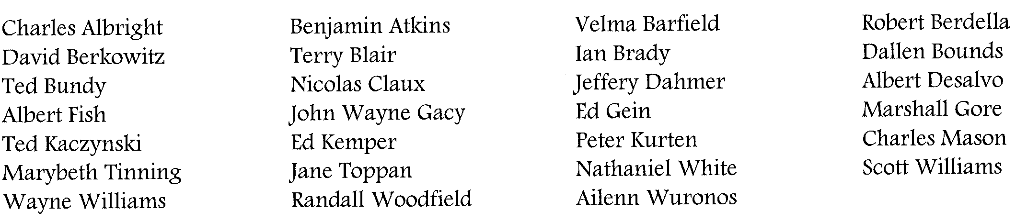

**Required Components**

**General:**

The box will need to be at least 13oz. and should be covered in paper or painted – none of the original artwork or pictures from the manufactured box should be visible. Use COLOR when appropriate to avoid the box being black and white, unless there is a solid creative reason for it to be so. Use well-chosen, appropriate pictures, timelines, various fonts, etc. Your final product should look as “professional” as a real cereal box that you’d find on the shelves at the store.

**Top:**

Your name, class period, and the name of your killer should be written neatly and clearly visible.

**Front:**

Use the front of your cereal box to “showcase” your killer. You should include nice graphics, catchy slogans, your cereal’s title displayed in an artsy way. You should have a clever manufacturer’s symbol as well.

**Back:**

Just like a real cereal box, you are to present the most important facts about the serial killer, time he/she committed the murders, how many victims, etc. Be creative in your presentation of facts! Many cereals have word searches, puzzles, riddles, graphic organizers, etc. that convey content in an entertaining way. Include a graphic organizer that relates all forensic evidence obtained on the case. Also, include a puzzle of some kind incorporating pertinent vocabulary in understanding this evidence and case, so that the average person not taking forensics could understand. (AT LEAST TEN WORDS) Do not forget to include the answers to your puzzles/riddles somewhere on your box. There will usually be placed upside-down on the bottom of the back of the box and are sometimes on the flap on the very bottom of the box.

Side 1:

Include a statement describing your killer’s *modus operandi*. Additionally, just as cereal boxes have a nutrition label describing what makes up their content, you should include something of a similar structure that describes the history of your serial killer. What events over the course of their life shaped who they became? What were the key turning points?

**Side 2:**

Explain the capture, trial, and sentencing of your serial killer, if applicable. How/when did they get caught? What evidence did the prosecution have against them? What was/is the ultimate fate of your serial killer? If your killer has not yet been caught, go into detail as to how they have managed to elude the authorities for so long. What evidence exists that will probably result in a conviction if this person is ever actually caught?

Inside:

Find or make a trinket that would represent a “prize” that some how symbolizes a key topic/idea related to your serial killer. Provide a tiny description as to how the trinket applies (or place the description on the front or back of the box in a promotional way). Place your bibliography, in APA format, inside your box as well. See the Purdue Online Writing Lab for APA citation standards.