**Unit 6: Biotechnology**

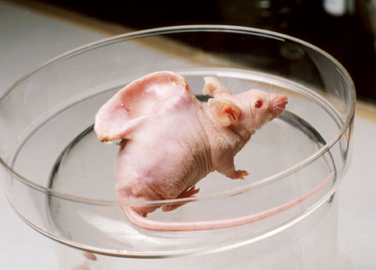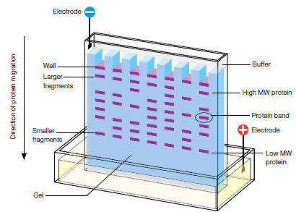

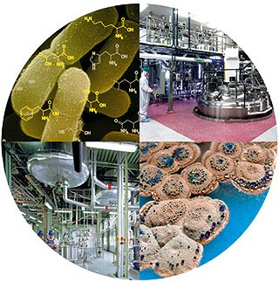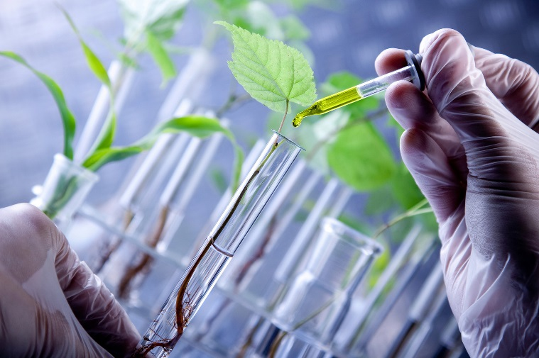

**Biotechnology Unit Key Take-Aways**

* Biotechnology is an important science, but remains controversial
* Gel electrophoresis allows scientists to identify individuals, endangered species, and discover evolutionary relationships between organisms
* Biotechnology is an important science, but remains controversial
* Key biotechnologies include: The Human Genome Project, cloning, stem cell research, gene therapy and transgenic organisms

**Introduction to Biotechnology**

**U6-1**

*While reading the article, do CLOSE reading strategies and answer the analysis questions at the end.*

**Introduction**

What do you think of when you hear the word “biotechnology”? Maybe things you’ve seen in the news, such as Dolly the cloned sheep, genetically modified organisms, or gene therapy.

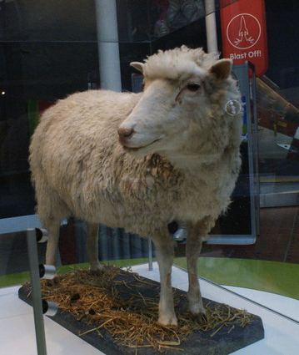

If that's what you think of, you’re absolutely right: these are all examples of biotechnology. But what about beer-brewing, crop breeding, and the antibiotic penicillin? These processes and products – some of which have been around for thousands of years – are also examples of biotechnology.

In this article, we’ll first examine the definition of biotechnology, seeing how it can encompass many different uses of organisms (and molecules or systems derived from organisms) to produce useful products. Then, we’ll take a closer look at DNA technology, techniques for manipulating and sequencing DNA. DNA technology is crucial to many modern forms of biotechnology.

*This image to the left is taxidermied remains of Dolly the cloned sheep, in the National Museums of Scotland, Edinburgh. Dolly was the first cloned mammal. That is, she was a genetically identical "copy" of another sheep.*

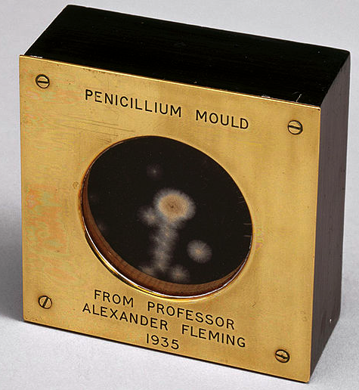**What is biotechnology?**

Biotechnology is the use of an organism, or a component of an organism or other biological system, to make a product or process for a specific use.

This is a very broad definition, and as mentioned above, it can include both cutting-edge laboratory techniques and traditional agricultural and culinary techniques that have been practiced for hundreds of years. Let’s look at three examples of biotechnology and see how they fit the definition:

**Beer brewing**. In beer brewing, tiny fungi (yeasts) are introduced into a solution of malted barley sugar, which they busily metabolize through a process called fermentation. The by-product of the fermentation is the alcohol that’s found in beer. Here, we see an organism – the yeast – being used to make a product for human consumption.

**Penicillin**. The antibiotic penicillin is generated by certain molds. To make small amounts of penicillin for use in early clinical trials, researchers had to grow up to 500 liters of “mold juice” a week. The process has since been improved for industrial production, with use of higher-producing mold strains and better culture conditions to increase yield.

*The image on the previous page is of a metal block with a glass window, containing a sample of penicillin-producing mold. The block was given by Alexander Fleming to Douglas Macleod.Image modified from "Sample of penicillin mould presented by Alexander Fleming to Douglas Macleod," (CC BY-SA 2.0).*

**U6-2**

**Gene therapy**. Gene therapy is an emerging technique used to treat genetic disorders that are caused by a nonfunctional gene. It works by delivering the “missing” gene’s DNA to the cells of the body. For instance, in the genetic disorder cystic fibrosis, people lack function of a gene for a chloride channel produced in the lungs. In a recent gene therapy clinical trial, a copy of the functional gene was inserted into a circular DNA molecule called a plasmid and delivered to patients’ lung cells in spheres of membrane (in the form of a spray).

​

In this example, biological components from different sources (a gene from humans, a plasmid originally from bacteria) were combined to make a new product that helped preserve lung function in cystic fibrosis patients.

As these examples show, biotechnology is used in the production of products we see in everyday life, such as alcohol and penicillin. It can also be used to develop new medical treatments, such as the gene therapy treatment for cystic fibrosis. Biotechnology has additional applications in areas such as food production and the remediation (cleanup) of environmental pollution.

**What is DNA technology?**

Many examples of modern biotechnology depend on the ability to analyze, manipulate, and cut and paste pieces of DNA. Approaches for the sequencing and manipulation of DNA are sometimes referred to as DNA technology. For example, for the cystic fibrosis gene therapy trial, researchers used DNA manipulation techniques to insert the chloride channel gene into a piece of carrier DNA (a vector) that allowed it to be expressed in human lung cells.

DNA technology is important to both basic and applied (practical) biology. For instance, a technique used to make many copies of a DNA sequence, called polymerase chain reaction (PCR), is used in many medical diagnostic tests and forensics applications as well as in basic laboratory research.

**Examples of DNA technologies**

Let's look at some examples of DNA analysis and manipulation techniques that are commonly used in modern molecular biology.

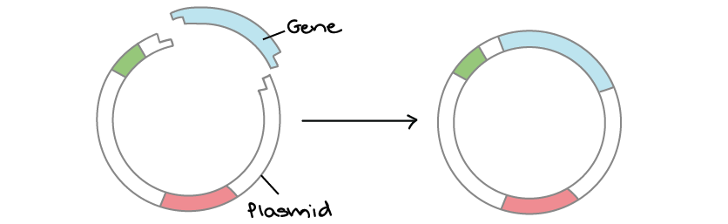**DNA cloning**. In DNA cloning, researchers “clone” – make many copies of – a DNA fragment of interest, such as a gene. In many cases, DNA cloning involves inserting a target gene into a circular DNA molecule called a plasmid. The plasmid can be replicated in bacteria, making many copies of the gene of interest. In some cases, the gene is also expressed in the bacteria, making a protein (such as the insulin used by diabetics).

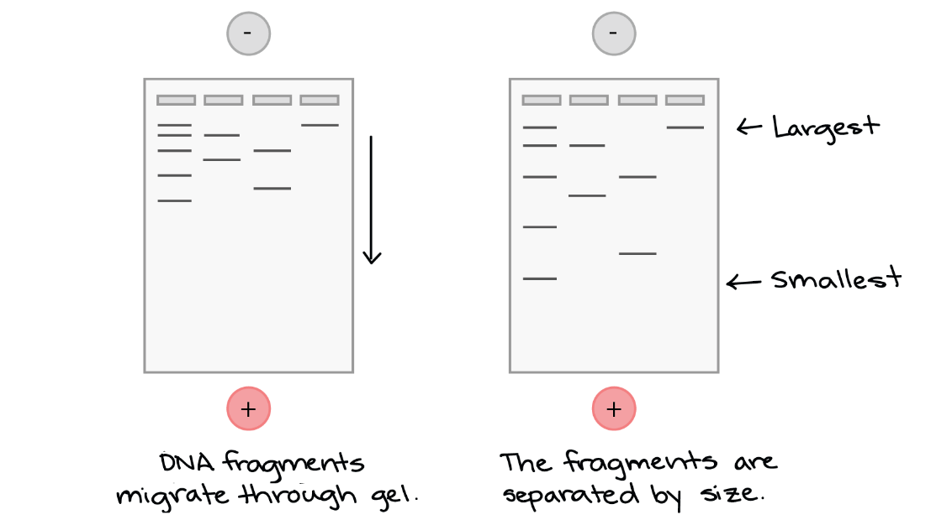**Gel electrophoresis**. Gel electrophoresis is a technique used to visualize (directly see) DNA fragments. For instance, researchers can analyze the results of a PCR reaction by examining the DNA fragments it produces on a gel. Gel electrophoresis separates DNA fragments based on their size, and the fragments are stained with a dye so the researcher can see them.

**U6-3**

*DNA fragments migrate through the gel from the negative to the positive electrode.*

*After the gel has run, the fragments are separated by size, with the smallest ones near the bottom (positive electrode) and the largest ones near the top (negative electrode).*

**DNA sequencing**. DNA sequencing involves determining the sequence of nucleotide bases (As, Ts, Cs, and Gs) in a DNA molecule. In some cases, just one piece of DNA is sequenced at a time, while in other cases, a large collection of DNA fragments (such as those from an entire genome) may be sequenced as a group. The Human Genome Project has been the largest on-going project since the mid-90s with the goal of sequencing the entire human DNA.

**Biotechnology raises new ethical questions**

Biotechnology has the potential to provide benefits to people and societies, but it can also have negative effects or unintended consequences. This is true of all forms of technology, not just biotechnology. However, biotechnology can offer different types of benefits and pose different types of dilemmas than other forms of technology.

It is important that biotechnology innovations (like other technological innovations) be carefully tested and analyzed before they are released for general use. Clinical trials and government regulation help ensure that biotechnology products placed on the market are safe and effective. However, sometimes new information becomes available that makes companies and government agencies reconsider the safety or utility of an innovation. We see this happening when a medication is occasionally withdrawn from the market.

In addition, biotechnology innovations may raise new ethical questions about how information, techniques, and knowledge should or shouldn’t be used.

* Some of these relate to privacy and non-discrimination. For instance should your health insurance company be able to charge you more if you have a gene variant that makes you likely to develop a disease? How would you feel if your school or employer had access to your genome?
* Other questions relate to the safety, health effects, or ecological impacts of biotechnologies. For example, crops genetically engineered to make their own insecticide reduce the need for chemical spraying, but also raise concerns about plants escaping into the wild or interbreeding with local populations (potentially causing unintended ecological consequences).
* Biotechnology may provide knowledge that creates hard dilemmas for individuals. For example, a couple may learn via prenatal testing that their fetus has a genetic disorder. Similarly, a person who has her genome sequenced for the sake of curiosity may learn that she is going to develop an incurable, late-onset genetic disease, such as Huntington's.

Scientific research and development can make new information, techniques, and knowledge available. However, science alone cannot answer questions about how these techniques should or shouldn’t be used. It's important for all members of society to have their voices heard in the conversation about biotechnology inventions and products that can affect our everyday lives.

**U6-4**

**Educate yourself and share your perspective**

Understanding the basic biology behind any form of biotechnology is an important first step in judging its benefits and potential pitfalls. The information in this section of the site will help you start building your toolkit to understand and evaluate new biotechnology inventions.

If you are curious about a specific type of biotechnology or concerned about its potential consequences, it is a great idea to do your own research. Seek out reliable, unbiased sources and strive to understand opinions from both sides if there is controversy. Make sure you fully grasp the science behind the invention, what is (and isn’t) known about it, and what the pros and cons are. Then, you will able to form your own thoughtful, well-supported opinion about whether and how the technology should be used.

**Analysis Questions**

1. In your own words, define biotechnology.
2. What is an example of biotechnology? Be sure to explain it!
3. What is DNA technology and how is it used in science today?
4. Explain the technology of gel electrophoresis.
5. Why is DNA sequencing important to the growing field of biotechnology?
6. Why might biotechnology raise ethical questions? Give a specific example to support your answer.

**What is Biotechnology?**

* Bio = _________
* Technology = the application of ____________ knowledge for some type of ___________ or useful outcome
* In other words, the practice of ________________ deals with the _____________ of living organisms or their components to _____________ a useful product
* There are several applications of biotechnology:
* _______________
* ______ ______________
* Human _____________ ___________________
* _______________ organisms
* _______ ______ research

|  |  |  |
| --- | --- | --- |
| **Biotechnology** | **Human Genome Project** | **Gene Therapy** |
| Vocabulary:  1.  2. | Vocabulary:  1.  2. | Vocabulary:  1.  2. |
| Write a definition for biotechnology. | What is the human genome project (HGP)? | What is gene therapy? |
| What does it mean to manipulate organisms?  Why do you think humans would want to select the characteristics an organism has? | List the 3 goals of the HGP:  1.  2.  3. | What is the role of the virus in gene therapy?  Describe a positive benefit of gene therapy. |
| **Video Questions** | **Video Questions** | **Video Questions** |
| 1. What is biotechnology?      1. All cells in our bodies have _______________ in the nucleus. 2. What is the goal of biotechnology? *To develop*… | 1. In what year did the human genome project start? __________ 2. How many base pairs were sequenced in the HGP? ____billion 3. Why did scientists want to read all of the human DNA? | 1. Corey could not see correctly because his _________ was mutated. 2. So, now that Corey’s eye has the correct sequence of DNA, his eye can make the ____________________ it needs to see again. 3. What carried the gene that Corey was missing? |

**U6-5**

**Intro to Biotechnology Stations**

|  |  |  |
| --- | --- | --- |
| **Stem Cell Research** | **Cloning** | **Transgenic Organisms** |
| Vocabulary:  1.  2.  3. | Vocabulary:  1.  2. | Vocabulary:  1.  2. |
| What are stem cells? | What is cloning? | What are transgenic organisms? |
| What is the difference between adult and embryonic stem cells? | What is a positive benefit from cloning? | What is a positive benefit of creating transgenic organisms? |
| Why is stem cell research controversial? | What is a negative aspect of cloning? | What is a negative aspect of transgenic organisms? |
| **Video Questions** | **Video Questions** | **Video Questions** |
| 1. Where can stem cells be found? 2. What “jobs” do stem cells have? What are they being used for today? | 1. Why was Tracker such an exceptional dog? 2. How did the scientists clone the dog Tracker?   *Scientists took ________ from Tracker and…* | 1. What is used now to snip or cut DNA? 2. What is used to make human insulin? 3. What are some other example of how scientists have used transgenic organisms? |

**U6-6**

**HUMAN GENOME PROJECT**

**U6-7**

|  |  |
| --- | --- |
| 1. What was the **Human Genome Project (HGP)**? | * A worldwide effort to _____________________ and __________________ every __________ of the human genome. * The outcome was a _______ of all human ________________________ with every gene’s _______ sequence and every human ___________. |
| 1. Why was the **HGP** established? | To provide _________________ information (a database) to use to help cure/treat/prevent _______________________________ (ie. ______________________) |

**GENE THERAPY**

|  |  |
| --- | --- |
| 1. What is **gene therapy**? | * A technique involving inserting a __________________ or healthy __________ into a cell to replace a faulty/defective gene. * Replace “________” genes with “_________” genes! |
| 1. How does gene therapy work? | 1. Use a _____________ to deliver the ______________ version of the gene into the cell. 2. Then the cell has the correct/working version of the gene. 3. The gene will then be used to make the correct ________________ for the individual. |
| 1. What are **viruses**? A tool for gene therapy | * Viruses are _____________ things with genes inside. * They inject DNA into a cell. * The virus serves as a ____________. A vector is a vehicle for moving genes. |
| 1. What are **2 disorders** involving defective genes that can possibly be treated by gene therapy? | 1. ___________ Fibrosis – buildup of sticky mucus in the lungs 2. ___________ Combined Immunodeficiency Syndrome (SCIDs) – autoimmune disorder that weakens the immune system |
| 1. What are the **BENEFITS** of gene therapy? | * Help ________________ diseases at the __________________ level. |
| 1. What are the **CONCERNS** of gene therapy? | 1. The virus may not insert the gene into the DNA _________________ 2. The technology is ______________________ and only accessible to the rich. 3. “Playing ________” |

**STEM CELLS**

**U6-8**

|  |  |
| --- | --- |
| 1. What are **STEM CELLS**? | * _____________________ and _____________________ cells * Do not have a specific _________________________ in the body yet * ______________________ * Have the __________ to become almost _______ cell in the body |
| 1. What are the **TWO MAIN TYPES** of stem cells? | 1. ______________________ Stem Cells (ESC)    1. Are the cells that form/come from the _______________ (fertilized egg) and are essential in the development of life    2. They have the ________________/_____________to become a wide variety of cells in the body    3. ___________ useful in stem cell research    4. Most controversial….*why*? 2. _____________ Stem Cell (ASC)    1. Cells that are present throughout life (found in _______ ________________ and a few other places) that help to generate new cells throughout life    2. Are less unspecialized and have the potential to become a _______ different types of cells    3. _________ controversial for research…*why*? |
| 1. What are **USES/BENEFITS** of stem cell research? | * Potential for curing ________________ ________________ like SCIDs and Cystic Fibrosis * Used to replace worn out or damaged ________ and tissues (like spinal cord injuries) or create new ones * ESC are more useful to ________________ because easier to manipulate (greater potential) * However, ASC are more easily _________________ |
| 1. What are **CONCERNS** of stem cell research? | * ESC destroys ________________ , and thus prevents a potential ________ * Potential to ________________ disease (like cancer if cells are programmed incorrectly) * “Playing ______” |

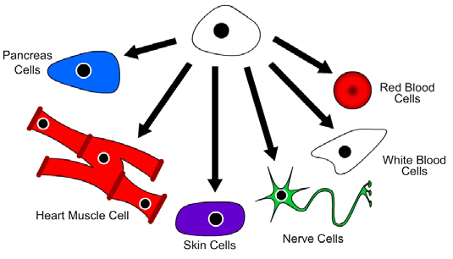 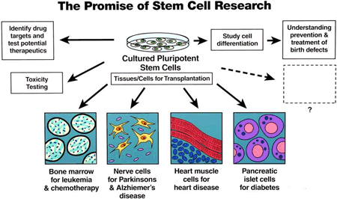

**Stem Cell**

**CLONING**

**U6-9**

|  |  |
| --- | --- |
| 1. What is **CLONING**? | 1. Creating _____ and __________________ organisms or tissues using biotechnology. 2. Cloning produces offspring that is ___________________identical to the parent |
| 1. What are the **STEPS** to create a clone? | 1. An _______ is taken from a _________ cell and the ___________ is removed. 2. The egg cell is ___________ with the ________ from another adult. 3. After they fuse, the cell begins to ___________ until it forms an ________________. 4. The embryo is placed into a female ______________ (foster mother). 5. The embryo grows and develops until it is born; it is genetically _________________ to the donor nucleus. |
| 1. What are the **BENEFITS**/**USES** of cloning? | 1. Help ___________________ _________ recover 2. Produce organisms with _________________ benefits (like to create donor organs) 3. Creating tissues for ________________ and for _________________ diseases |
| 1. What is the **CONCERN** of cloning? | * Fear of cloning ________________ * “Playing _______” (just because we *can,* should we?) |
| 1. Who was **DOLLY**? What happened to her? | * Dolly was a ___________ and was the ___________ cloned animal from an adult cell. * All clones before her had come from an embryo. * Dolly suffered from many ____________ issues and died at an __________ age. |

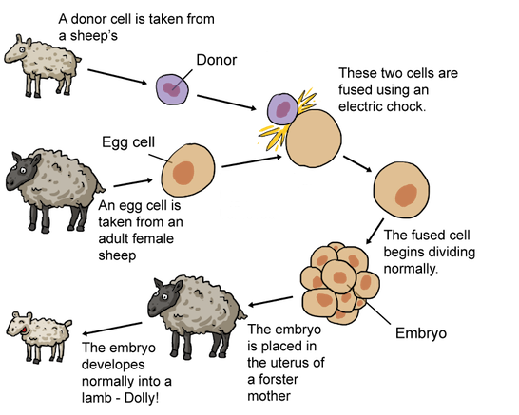**CLONING**

**U6-10**

**TRANSGENIC ORGANISMS**

**U6-11**

|  |  |
| --- | --- |
| 1. What is **RECOMBINANT** **DNA**? | * Combined DNA from 2 different organisms (often a plasmid) |
| 1. What are **TRANSGENIC ORGANISMS**? | * It is an organism that has had genes ____________ (or moved into) to it from a different organism. * Transgenic organisms are made from ___________________ DNA. * Also known as recombinant ____ technology, ______________ engineering, genetically modified organisms, genetically modified crops |
| 1. What is a **GENETICALLY MODIFIED FOOD/ORGANISM (GMO)?** | * It is a crop or organism that has been **________________** altered or changed. * Examples of GMOs:  1. Transgenic microorganisms (bacteria)  * Can be used to make human __________ hormone, ____________, and clean up the environment  1. Transgenic plants  * Can be made _________ resistant, frost resistant, _________ resistant, larger, and contain added _______________  1. Transgenic animals  * Cows and ______________ can produce more _________ which increases the food supply |
| 1. What are the **steps** to create a transgenic organism? | 1. ________________ & cut out the good gene you want  What do you use to cut out the gene?  _____________________ ENZYME   1. Remove a _____________ from a bacterial cell   What is a plasmid?  CIRCULAR PIECE OF __________________ _______  3. ______________ (attach) the human DNA to the plasmid  4. Insert the ______________________ ___________ back into the bacteria  5. Let the bacteria ___________ , making more copies of the human gene |
| 1. What are the **BENEFITS**/**USES** of transgenic organisms? | * Improve human health 🡪 scientists can use transgenic bacteria to produce large amounts of human proteins such as _______________ hormone and ________ (diabetics) * The ___________ in this example is considered _________________ organism * Improve food production 🡪 crops can be genetically engineered to grow larger and __________, resist __________ and resist __________or frost. |
| 1. What are the **CONCERNS** of transgenic organisms? | * May spread ____________ or carry toxins * May contribute to _____________ * Spread unwanted__________ into the environment |

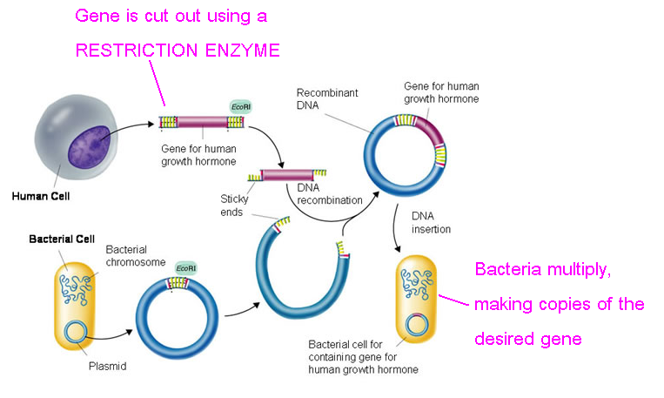 **TRANSGENIC ORGANISMS**

**U6-12**

**GEL ELECTROPHORESIS**

**U6-13**

A Biotechnology Tool that _____________________ DNA according to ___________

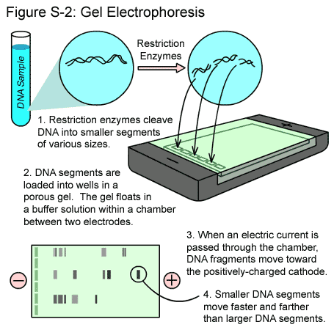

End Result of Using Gel Electrophoresis is a

**DNA FINGERPRINT**

**Uses for DNA Fingerprints**

**(and the gel electrophoresis process):**

1. Identify a ______________________ or suspect in a crime
2. Determine the _____________________ of a child
3. Identify and catalogue ________________________ or extinct species
4. Determine evolutionary _____________________ of ________________________ species

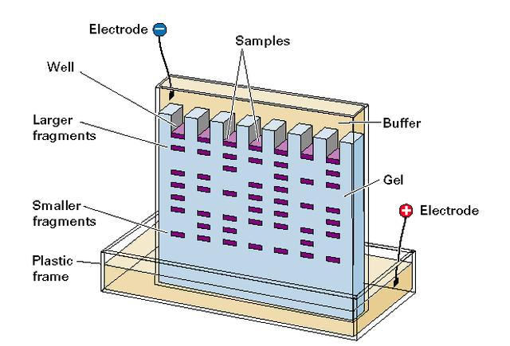

**U6-14**

**HOW TO ANALYZE A DNA FINGERPRINT**

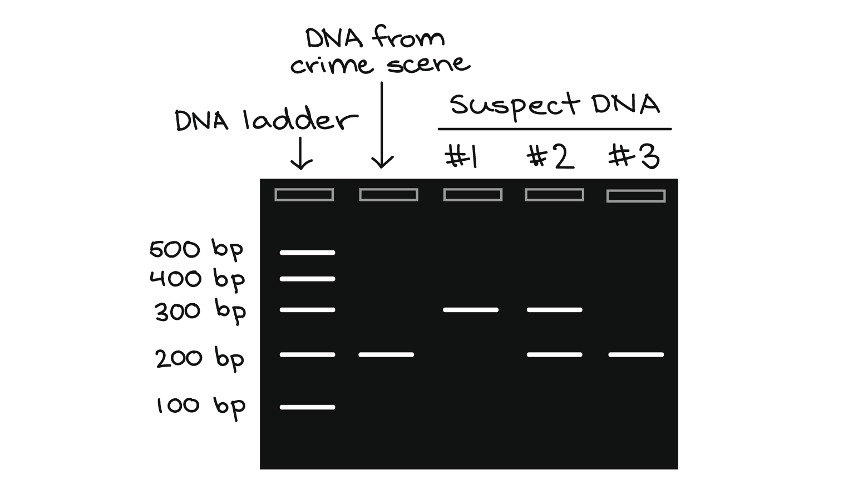

**DNA Fingerprints can be used to match crime scene DNA to suspects.**

* For this type of analysis, the DNA must be an ***exact*** match.
* Which suspect was at the crime scene?

**DNA** **Fingerprints can be used to determine paternity of a child.**

* Each DNA band in the child must match up to either the Mom or the Dad.
* Which male is the father of this child?

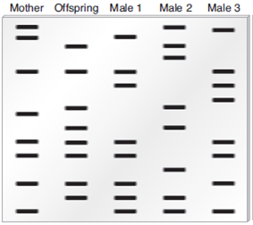

DNA Fingerprints can be used to identify unknown species or compare how related 2 species are.

* For this type of analysis, find the species with the most similarities.
* Which two species are most closely related?

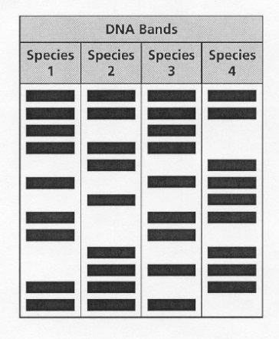

**DNA Fingerprints can be used to identify unknown species or compare how related 2 species are.**

* For this type of analysis, find the species with the most similarities.
* Which two species are most closely related?

**Review Questions:**

1. What is gel electrophoresis?
2. What is a DNA Fingerprint?
3. Can 2 people have the same DNA fingerprint? Explain.

**Gel Electrophoresis & DNA Fingerprinting**

**U6-15**

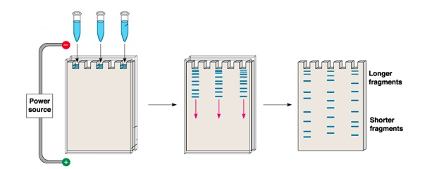

1. Take a DNA sample and cut it apart using a ____________________ _____________

2. Inject DNA fragments into _______ ______________________

3. Run electrical current through GEL…DNA will move to ______________ end because DNA is _________________charged

Everyone’s DNA cuts apart into _______________ size pieces, because everyone has a ______________ sequence of nitrogen bases (ATCG)

Smaller DNA pieces will move _____________ & larger DNA will move _________

**DNA Fingerprint**

**Biotechnology Study Guide**

**U6-16**

**Part I: Vocabulary**

Fill in the blanks using any of the following terms for question 1-14.

**Human Genome Plasmid Transgenic organism Recombinant DNA**

**Cloning Restriction enzyme DNA fingerprint Genetic engineering**

**Stem Cell Gene Therapy Vector Gel Electrophoresis**

**Human Genome Project Genetically Modified Organism (GMO)**

1. A(n) ________________________________________ is a small, circular piece of DNA found in bacterial cells.
2. _________________________________________ is the result of a test used to determine paternity or help identify a crime suspect.
3. _________________________________________ is the process by which identical copies of cells, tissue, or organisms are produced.
4. The entire collection of genes within human cells is referred to as the ______________________________
5. A specialized _____________________________________________ is used to cut DNA into fragments/pieces.
6. _______________________________________________ refers to any process or technique involved in manipulating or changing genes.
7. _____________________________ are undifferentiated cells that may become any type of cell in the body.
8. The _____________________________________________________ was a global initiative that sought to map all the gene sequences in the human genome with hopes to create a database and research tool to help cure human genetic diseases.
9. One of the goals of the Human Genome Project was to be able to cure genetic diseases by finding and replacing faulty genes with working genes using viruses or other vectors in a process known as ______________________ ____________________________.
10. A ________________ _________________________ is produced when DNA from a different species is inserted into the genome of an organism, which then begins to use the DNA as its own. Examples of these are Bt corn and “super salmon.”
11. The procedure used to create a DNA fingerprint is _________________ _______________________________
12. This is a type of DNA created when a gene from one organism is inserted into the DNA of another organism: ___________________________________ _____________.
13. An agent such as a plasmid, virus, or bacteriophage that is used in genetic engineering to transfer a segment of DNA into a bacterium or cell is called a ___________________________.
14. What is another term used to describe a transgenic organism? _______________ ________________ _______________(_____)

**Part II: Human Genome Project**

1. Describe the Human Genome Project. What did scientists do?
2. List reasons for establishing the Human Genome Project.

**Part III: Genetic Engineering**

**U6-17**

1. How is recombinant DNA *different* from a transgenic organism?
2. Put the following steps to creating a transgenic organism in order:
   1. ____ Put the DNA back into Organism 2
   2. ____ Insert the DNA into the DNA of Organism 2 (mix them)
   3. ____ Take the desired gene from Organism 1, cut with enzymes
   4. ____ Organism 2 has a new trait
   5. ____ Organism 2 makes copies of the cells (asexual reproduction)

***In 1973, two scientists took a gene from an African clawed frog and inserted it into a bacterium. The bacterium then began producing a protein directed by the gene from the frog.***

2. In the scenario above, the African clawed frog is the:

a) transgenic organism b) a clone

c) recombinant DNA d) the source of the working gene

3. In the scenario above, the bacterium is the:

a) transgenic organism b) a clone

c) recombinant DNA d) the source of the working gene

**4. Describe or explain how genetic engineering (biotechnology) is used in creating human insulin step by step. Put these steps in the correct order (1-5).**

____ The insulin gene is turned on (expressed) in the bacterial clones and the insulin protein is extracted and bottled up for the patient.

____ A restriction enzyme is also used to cut open a plasmid from a bacterial cell

____ The insulin gene is inserted into (combined with) the bacterial plasmid to create recombinant DNA (DNA from two different organisms).

____ A restriction enzyme is used to cut the insulin gene out of a human cell.

____ The recombinant plasmid is inserted into a bacterial cell to reproduce.

5. Label the diagram below using the terms:

***Recombinant DNA, Plasmid, Foreign DNA***

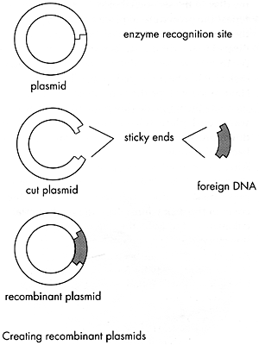

6. From what type of organism did this plasmid come from? ________________________________

7. What will the geneticist do with the recombinant DNA plasmid now? _________________________________ ______________________________________________

8. In the diagram below:

**U6-18**

* 1. Draw a square around a **cut plasmid**.
  2. Draw a circle around **recombinant DNA**.
  3. Explain why the bacteria cell is considered **transgenic**.
  4. What type (*mitosis or meiosis*) of cell division will the bacteria go through?

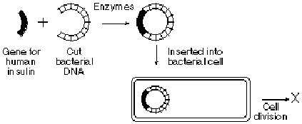

**Part IV: Gel Electrophoresis and DNA Fingerprinting**

**Below is a DNA fingerprint made by the process of gel electrophoresis.**



1. What do the bands represent?
2. Explain how DNA is separated during a gel electrophoresis.
3. According to the DNA

Fingerprint, which suspect was at the crime scene?

1. Highlight the SHORTEST/SMALLEST DNA fragment in the “Crime Scene DNA” column.

**Part V – Cloning**

*Describe the missing steps involved in cloning Dolly the Sheep.*

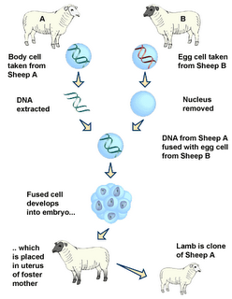

2. _________________ is removed

3.

1.

4.

5. Why is the nucleus removed from the egg cell of the donor sheep?

**U6-19**

**Part VI – Stem Cells**

1. What is a stem cell?
2. How are stem cells different from normal body cells?
3. How is an embryonic stem cell different from an adult stem cell?

**VII – Gene Therapy**

1. What is gene therapy?
2. What kind of diseases or illnesses do scientists hope to treat/cure using gene therapy?
3. How does gene therapy use vectors? (like a virus)

**SHORT RESPONSE**. Select 3 of the 6 topics below and fill out the chart below. Include 2 evidences to support the claim either “for” or “against” the use of this technology.

Biotechnology topics (choose 3)

1. Human Genome Project (HGP)
2. Therapeutic Cloning
3. Human Cloning
4. Gene Therapy
5. GMOs (Genetically Modified Organisms)
6. Embryonic Stem Cell Research

|  |  |  |  |
| --- | --- | --- | --- |
| **Choice** | **Reasons For** | **Reasons Against** | **Evidence/Explanation** |
|  |  |  |  |
|  |  |  |  |
|  |  |  |  |